University of Mannheim
Department of Economics
Chair of Statistics

Bachelor’s thesis
Prof. Dr. Christoph Rothe

Covid Measures in German States under the Hotspot Regulation -

an Empiric Policy Evaluation

Submitted on January 30, 2023

Maximilian Reith
Student ID: 1690571
E-Mail: mreith@mail.uni-mannheim.de
Address: O7 29, 68161 Mannheim
Content
1. Introduction 1
2. Presenting the context 1
3. Empirical Strategy 4
3.1. Data 4
3.2. The Synthetic Control Method 6
3.3. Estimation Setups 7
4. Results 9
4.1. COVID-Cases 9
4.1.1. Mecklenburg-Vorpommern 10
4.1.2. Hamburg 15
4.2. Hospitalizations 17
4.2.1. Mecklenburg-Vorpommern 18
4.2.2. Hamburg 20
4.3. A Possible Control of Spillover Effects 22
5. Concluding Remarks 24
Publication bibliography 26
Appendix 29
Affidavit 34

Introduction
In April 2022, the German states of Hamburg and Mecklenburg-Vorpommern were the only states to uphold a series of containment measures against the spread of COVID-19 that had been dropped in other states due to a change in national legislation. This setting provides a good natural experiment to evaluate the causal effects of these restrictions. In this paper, an empirical strategy based on the synthetic control method is employed, estimating the restrictions’ effects on COVID-19 cases and hospitalizations.
Abadie (2021) provides a recent overview over the synthetic control method. Synthetic controls have been used for quantitative comparative case studies in various fields such as economics, political science, and epidemiology to estimate the causal effect of policies on a wide range of outcomes such as economic growth, crime rates, and health outcomes (see for example Abadie et al. 2015, Cunningham and Shah 2018, and Abadie et al. 2010).
Applying the synthetic control method to the course of the COVID-19 pandemic in Germany in the spring of 2022, this study finds no effects of the additional restrictions on the spread of COVID-19 and hospitalizations of patients infected in Hamburg and Mecklenburg-Vorpommern. The context and background are presented in section 2. Section 3 explains the data and empirical strategy, while section 4 contains the results. Section 5 contains a brief discussion and concluding remarks. Additional figures are provided in the Appendix.

Presenting the context
In Germany, the Infection Protection Act (Infektionsschutzgesetz) is a federal law that has been providing the legal basis for states to enact coronavirus restrictions. Throughout the COVID-19 pandemic, the Infection Protection Act has been changed and adapted multiple times. With the expiration of the law’s current form in March 2022, the German Bundestag passed a new version which established more stringent requirements for states to implement containment measures (Bundesgesetzblatt 2022). In the media, the law’s corresponding passage was referred to as the Hotspot Regulation: only by declaring themselves a hotspot were states provided with the legal fundament to implement containment measures.
This change to the legal framework was met with a lot of criticism by state authorities, who pointed out that the Hotspot Regulation set too high and narrow requirements for states to be able to declare themselves a hotspot: a precondition was either the spread of a covid variant that was especially dangerous or the threat of overburdening regional health care capacities due to a sharp rise in cases. Subsequently, while states like North Rhine-Westphalia, Saxony, Thuringia, Lower Saxony, and Baden-Württemberg declared their initial intentions to make use of the Hotspot Regulation, they retracted citing the concern that, given the proclaimed requirements, the ascertainment of a hotspot would most likely be successfully challenged in court. Political restraints might have been an additional obstacle, as in some states (like North Rhine-Westphalia and Thuringia) governing parties lacked the support of their coalitional partners or of other parliamentary fractions to acquire the necessary majority in the state parliament (Burger et al. 2022; Busche 2022).
Consequently, only two states, Hamburg and Mecklenburg-Vorpommern, declared themselves as a hotspot and made use of the Hotspot Regulation (Sozialbehörde der Stadt Hamburg 2022b; Ministerium für Soziales, Gesundheit und Sport 2022; Bingener and Burger 2022). While the restrictions were successfully challenged in court in Mecklenburg-Vorpommern and mostly uplifted on April 22, a few requirements were in place until April 28 (NDR 2022). In Hamburg, the corresponding regulations were in place until April 30 without a court interfering, but were not extended thereafter (Sozialbehörde der Stadt Hamburg 2022a). Therefore, for a period of 20 days, or 30 respectively, Mecklenburg-Vorpommern and Hamburg were the only states to impose a series of containment measures, including mandatory FFP2 masks for indoor shopping, events, and restaurants. Additionally, only in these states it was required to show a proof of vaccination to enter a nightclub. Other measures, like the mandate to wear an FFP2 mask in medical facilities, nursing homes, or in public transport were still in place in all German states.

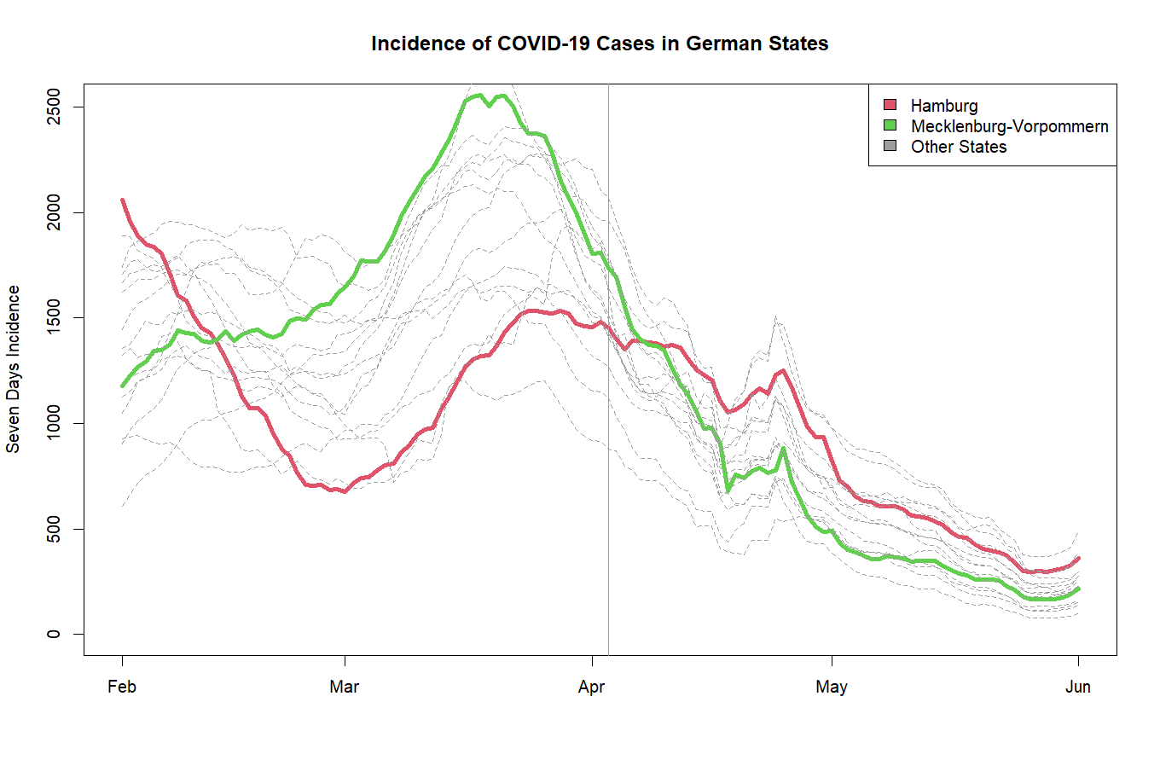
Figure 1: The green line represents the seven-days incidence of Mecklenburg-Vorpommern, the red line the one of Hamburg. The grey lines represent the seven-days incidences of the other 14 German states. The seven-days incidence is calculated as COVID-19 cases within the last seven days per 100,000 inhabitants. The vertical line displays April 3, the day on which containment measures were lifted in 14 out of 16 German states.
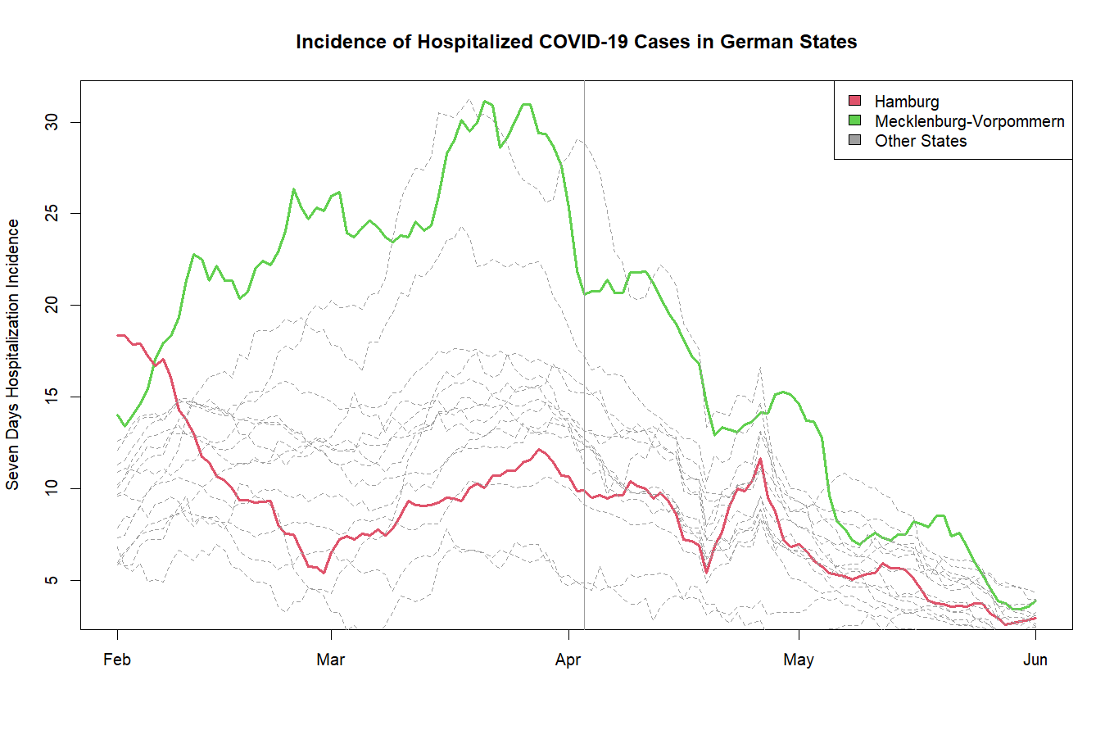
Figure 2: The seven-days hospitalization incidence is calculated as hospitalized COVID-19 cases within the last seven days per 100,000 inhabitants. The vertical line displays April 3, the day on which containment measures were lifted in 14 out of 16 German states.
Figure 1 and figure 2 show the seven-days COVID incidence and the seven-days hospitalization incidence of Hamburg and Mecklenburg-Vorpommern compared to other German states. As can be seen, Hamburg had a comparatively low COVID and hospitalization incidence, while Mecklenburg-Vorpommern had rather high numbers. As it was mostly political and legal factors that determined states’ decision to make use of the Hotspot Regulation, this setting makes an interesting natural experiment to evaluate the effects of the additional COVID measures imposed under the Hotspot Regulation in Hamburg and Mecklenburg-Vorpommern.

Empirical Strategy

Data
Data on the main outcome variables, COVID-19 cases as well as hospitalizations of patients infected with COVID-19, is obtained from the Robert Koch Institute (RKI) (2022a, 2022c), which is the German government’s central institution for the identification, surveillance, and prevention of diseases. Most COVID-19 cases are identified by doctors or testing laboratories, who report these cases to the local health authority (Gesundheitsamt), which then transmits all newly registered cases to the Robert Koch Institute. As the date of infection cannot be determined in most cases, the Robert Koch Institute uses the report date (Meldedatum) as a reference date for newly registered cases, which is the date on which the local health authority registered the positive test result of a patient (Robert Koch Institut 2022a). There usually is a time delay between the date of infection and the report date, as it takes time for patients to develop symptoms, visit a testing facility, the taken test to be evaluated, and positive results to be reported to the health authority. It is also noteworthy that fewer cases are reported on weekends or holidays, as doctor’s offices or laboratories are often closed. This should be kept in mind during the analysis, as there are multiple holidays in the post-treatment period, namely the Easter holidays (Good Friday on April 15 and Easter Monday on April 18) and Labor Day (on May 1).
Hospitalizations of patients infected with COVID-19 are reported in a similar manner: hospitals or doctors report the hospitalization of a patient to the local health authority, which transmits all newly registered hospitalizations to the RKI. As a reference date for a hospitalization, the RKI again uses the report date of the positive test result of a patient, as the actual date of hospitalization is not reported in many cases. Depending on the infection and reporting history, the report date may be before, concurrent with, or even after the hospitalization date. However, available hospitalization dates show that both are often close together. The RKI warns that data on current hospitalizations is underreported, given the time delay in reporting, and provides an estimate for current hospitalizations (the “adjusted hospitalization incidence”) instead. But as the studied period lies well in the past, the underreporting of hospitalizations due to a time delay is of no concern to this study (Robert Koch Institut 2022c).
Furthermore, the geographic assignment of hospitalizations in the data should be pointed out. A hospitalization is reported for the state of residence of a patient, which is not necessarily the state in which the patient is hospitalized in. This assignment mechanism is beneficial to this analysis, which focuses on the containment measures’ effects on infections and hospitalizations within the populations of Hamburg and Mecklenburg-Vorpommern. It is therefore helpful that a patient from the state of Schleswig-Holstein who is moved to a hospital in Hamburg, for example, does not distort Hamburg’s hospitalization incidence (Robert Koch Institut 2022c).
Additionally, data on population numbers is obtained from the Federal Statistical Office of Germany (2022). Data on unemployment is taken from the Joint Statistics Portal of the Federal and State Governments (2021). Data of vaccinations against COVID-19 in Germany is also obtained from the Robert Koch Institute (2022b). All these data sets contain data on both a state and a municipality level. Finally, it should be noted that unlike with hospitalizations, vaccinations are not reported for the place of residence of a patient, but instead for the location where the patient was vaccinated. This can lead to a distortion of vaccination rates, especially on the municipality level, when comparing the vaccination rates of cities and rural regions.

The Synthetic Control Method
The synthetic control method was first introduced by Abadie and Gardeazabal (2003). Since then, the method has evolved to become a widely utilized method in applied econometrics, leading Athey and Imbens (2017) to call it the “arguably […] most important innovation in the policy evaluation literature in the last 15 years.”
Used for quantitative comparative case studies, the synthetic control method estimates a counterfactual for a treated unit by constructing a weighted average out of a group of corresponding units (often referred to as the donor pool). This counterfactual, called the synthetic control, is supposed to represent the post-treatment outcome path of the treated unit, if the treatment had never occurred. The synthetic control framework is a “powerful, yet surprisingly simple generalization of the difference-in-differences strategy” (Cunningham 2021). In the presence of common factors that cause a considerable amount of co-movement among the treated unit and the comparison units, the synthetic control provides a credible counterfactual (Abadie 2021). Given the context and the parallel trends observed in figure 1 and figure 2, I argue that this condition is being met in the presented setting.
The notation employed here follows Abadie (2021). Let there be $J+1$ units, where $j=1$ is a unit affected by a treatment and $j=2,…, J+1$ are the units unaffected by the treatment that make up the comparison group. Let $Y_{jt}$ be the outcome variable of unit $j$, which is observed over multiple periods $t=1, …, T$. $Y_{jt}$ is observed before and after the treatment, where $T_{0}$ is the last period before the treatment takes effect, therefore $1<T_{o}<T$. There are also $k$ predictors of the outcome variable being observed for each unit, denoted as $X_{jk}$. The $k×1$ vectors $X_{1},… , X_{J+1}$ contain the predictors of the according units. The $k×J$ matrix $X_{0}=[X_{2},… , X_{J+1}]$ contains the predictors of all $J$ untreated units.
The idea of synthetic controls is to estimate the effect $τ_{t}=Y_{1t}^{I}-Y_{1t}^{N}$ for $t>T_{o}$, where $Y_{1t}^{I}$ is the outcome of the treated unit, if actually treated, while $Y_{1t}^{N}$ is the outcome of the treated unit not being affected by the treatment. Of course, only one of them is observed and $Y_{1t}=Y_{1t}^{N}$ for $t≤T_{o}$ and ${ Y}_{1t}=Y_{1t}^{I}$for $t>T_{o}$. Thus, the path of the outcome variable in the absence of a treatment $Y_{1t}^{N}$ is estimated for $t>T_{o}$ with a synthetic control ${\hat{Y}}_{1t}^{N}.$ A synthetic control can be denoted with a $J×1$ vector of weights $W=(w_{2},…,w_{J+1})'$ , where $\sum_{j=2}^{J+1}{w_{j}}=1$ and $0≤w_{j}≤1$ to avoid extrapolation. Synthetic control estimators for $Y_{1t}^{N}$ and the treatment effect $τ_{t}$ in $t=T_{o}+1, …, T$ then are
 | $${\hat{Y}}_{1t}^{N}=\sum_{j=2}^{J+1}{w_{j}}Y_{jt}$$ | (1)
 | ${\hat{τ}}_{t}=Y_{1t}-\sum_{j=2}^{J+1}{w_{j}}Y_{jt}$. | (2)
The weights $W$ are to be chosen so that the synthetic control best resembles the pre-intervention values of the predictors of the outcome variable. Therefore, following Abadie and Gardeazabal (2003) and Abadie et al. (2010), the vector $W^{*}=(w_{2}^{*}, …, w_{J+1}^{*})$ that minimizes the norm
 | $$\left\|X_{1}-X_{0}\left.W\right\|\right.={\left(\sum_{h=1}^{k}{v_{h}{(X_{h1}-w_{2}X_{h2}-…-w_{J+1}X_{hJ+1})}^{2}}\right)}^{\frac{1}{2}}$$ | (3)
is chosen. $v_{h}$ is an element of the $k×1$ vector $V=(v_{1},…, v_{k})'$ with $\sum_{h=1}^{k}{v_{h}}=1$ and $0≤v_{h}≤1$. The values of $v_{h}$ represent the relative importance of a treated unit’s predictor being closely matched by its synthetic control. There are different approaches on how to choose $V$. In this study, I will use an approach used in Abadie and Gardeazabal (2003) and Abadie et al. (2010), where $V$ is chosen so that the corresponding synthetic control minimizes the mean squared prediction error (MSPE) of the synthetic control with respect to $Y_{1t}$ over all included pretreatment periods:
 | $\frac{1}{T_{0}}\sum_{t=1}^{T_{0}}{{(Y_{1t}-w_{2}\left(V\right)Y_{2t}-…-w_{J+1}\left(V\right)Y_{J+1t})}^{2}}$. | (4)
The results are obtained by using the R package synth, presented in Abadie et al. (2011).

Estimation Setups
Next, the chosen estimation frameworks are discussed. Usually, synthetic controls are applied in settings where one aggregated unit is exposed to a treatment. As there are two units, Hamburg, and Mecklenburg-Vorpommern, exposed, one could aggregate them to one combined unit. However, estimating effects for a combined unit would be at the risk of neglecting distinct characteristics of these states, characteristics which might cause the application of the Hotspot Regulation to have different effects. Hamburg and Mecklenburg-Vorpommern differ not only in the pre-treatment path of COVID cases and hospitalizations, as Hamburg has the highest GDP per capita of all German states, and Mecklenburg-Vorpommern has the lowest (Gemeinsames Statistikportal des Bundes und der Länder 2022). Hamburg is also both the second biggest city in Germany and a state, while Mecklenburg-Vorpommern has the lowest population density of all states. Given these considerable differences, synthetic controls for Hamburg and Mecklenburg-Vorpommern will be estimated separately.
Turning to the dependent variables, all estimations presented in section 4 will rely on 14-days incidences, either as growth rates or as levels. While the seven-days incidence is the most common modification of COVID cases and hospitalizations, averaging over 14 days comes with the advantage of reducing the amount of noise in the data substantially. This shows especially around the Easter holidays, where the 14-days incidences of COVID cases, hospitalizations, and their growth rates do not show strong fluctuations, instead displaying only long-term developments. In subsection 4.1., two synthetic controls will be estimated with the growth rate of the 14-days incidence of COVID cases as the dependent variable. In subsection 4.2., the dependent variable for Mecklenburg-Vorpommern is the growth rate of the 14-days hospitalization incidence. For Hamburg, a dependent variable in levels is chosen instead, as using the growth rate does not yield a good pre-treatment fit there.
All states except for Mecklenburg-Vorpommern and Hamburg lifted their containment measures on Sunday, April 3 (Burger et al. 2022). The selected sample period includes the six weeks prior to the treatment. The post-treatment timeframe includes the entire time span where both states differed in their containment measures plus an additional two weeks, as data on COVID cases and hospitalizations usually comes with a time lag. Therefore, the pre-treatment period includes the 42 days from February 21 to April 3, and the post-treatment period includes the 42 days from April 4 to May 15.
Regarding the donor pool, all other states except for the city states of Hamburg, Bremen, and Berlin serve as the comparison group for Mecklenburg-Vorpommern. Choosing a comparison group for Hamburg is more ambiguous: both cities and states can be chosen as a comparison group for Hamburg’s growth rate of COVID cases, and both provide similar estimation results. The estimation results presented in subsection 4.1 select the 15 biggest cities in Germany as a sample. For an analysis of the effects on Hamburg’s hospitalization incidence, the other German states are chosen as a comparison group, given the lack of hospitalization data on the municipality level.
To finalize the set-up, the selected predictors incorporate the population density of a state (per square kilometer), its unemployment rate, and the ratio of its population having received a booster vaccination by April 3. Unemployment rates are utilized as they serve as a proxy for the socio-economic conditions in a state, while vaccination rates not only indicate the immunization of a state’s population, but also hint at the population’s attitude towards government recommendations and policies regarding the pandemic. Finally, a set of pre-treatment outcome variables is also included.

Results
In this section, I will first display the findings for the growth rate of the 14-days incidence of Mecklenburg-Vorpommern and Hamburg in subsection 4.1., before moving to estimations with the 14-days hospitalizations incidence, or its growth rate respectively, in subsection 4.2. Subsection 4.3. then presents an attempt to control for interference among treated and untreated units.

COVID-Cases
First, two synthetic controls are estimated to evaluate the effect of the measures implemented on COVID infections in Mecklenburg-Vorpommern and Hamburg. Here, the growth rate of the 14-days COVID incidence is used as the dependent variable. Similar outcomes can be obtained in estimations that use a dependent variable in levels, like the 14-days COVID incidence or seven-days COVID incidence presented in figure 1.

Mecklenburg-Vorpommern
Figure 3 displays the growth rate of the 14-days COVID incidence in Mecklenburg-Vorpommern and the mean growth rate of the units in the donor pool. While the donor pool’s mean growth rate follows a similar direction, it fails to match the path of Mecklenburg-Vorpommern’s incidence growth in the pre-treatment period. Figure 4 displays the estimated synthetic control for Mecklenburg-Vorpommern.
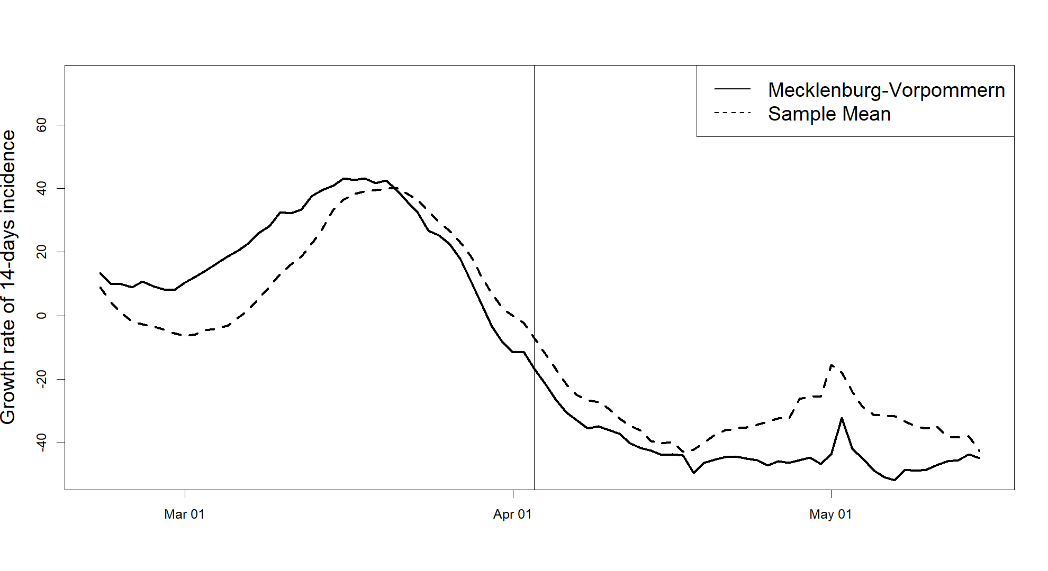
Figure 3: Comparison of the growth rate of the 14-days COVID incidence of Mecklenburg-Vorpommern to a donor pool average. The vertical line displays April 3, the day on which containment measures were lifted in 14 out of 16 German states.
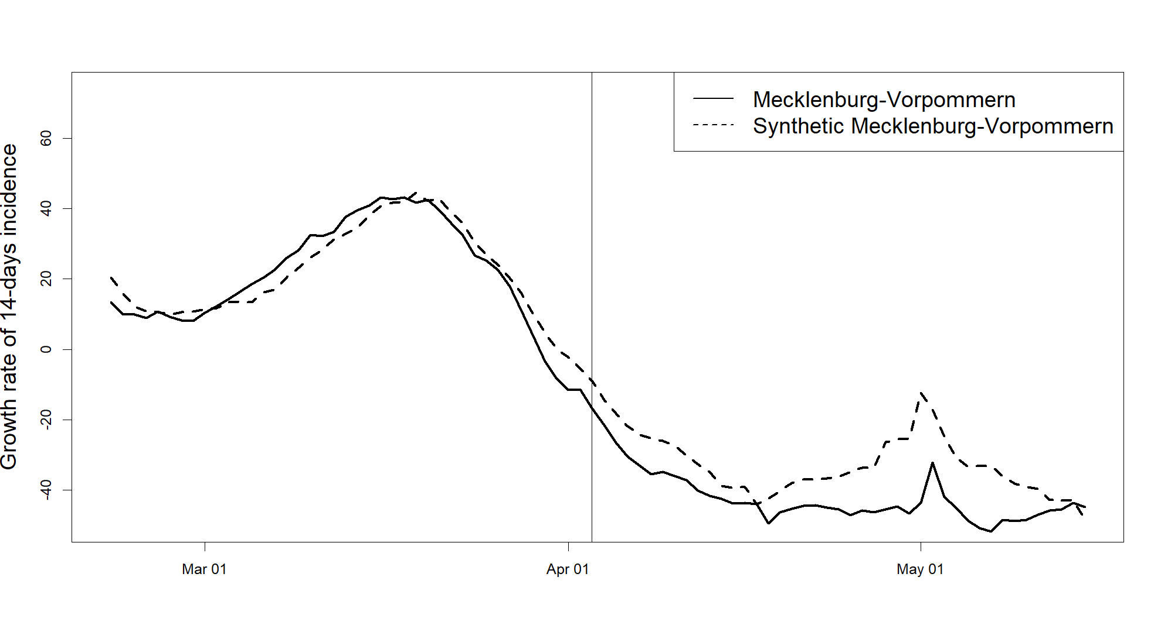
Figure 4: Comparison of the growth rate of the 14-days COVID incidence of Mecklenburg-Vorpommern to its synthetic control, according to equation (1) and the weights $w$ displayed in table 2.

As can be seen, the synthetic control in figure 4 provides a better fit for Mecklenburg-Vorpommern, matching the state’s path with only a small gap widening before April 3. After the treatment, there is a wider gap between the two growth rates from the middle of April until the end of the observation period, with a spike in growth rates around May 1. This spike results from a disruption in case reporting around the easter holidays, when case numbers were underreported from Good Friday (April 15) to Easter Monday (April 18). While there is an observable gap between the treated unit and the synthetic control, by presenting a mode of inference and robustness checks, I will argue that this gap does not indicate an effect of significant size.
Table 1: Predictor values and weights
Predictor | MV | Synthetic MV | Sample Mean | weight $v$
Growth rate on March 6 | 20.4 | 16.3 | -0.8 | 0.004
Growth rate on March 20 | 42.6 | 42.3 | 40.0 | 0.524
Growth rate on April 3 | -16.7 | -8.9 | -7.0 | 0.017
Unemployment rate | 8.3 | 6.2 | 6.1 | 0.001
Population density | 69 | 137 | 234 | 0.068
Ratio of population having received a booster vaccination | 0.579 | 0.578 | 0.594 | 0.387
Note: The predictor’s weights are chosen by minimizing equation (4). Sample mean refers to the mean of the selected comparison group, not including the treated unit. Growth rate refers to the growth rate of the 14-days COVID incidence.
Table 1 displays the predictors weights of Mecklenburg-Vorpommern (MV), its synthetic counterpart, and the mean of the selected sample. The predictors of Mecklenburg-Vorpommern are much closer to the synthetic control than to the mean of units in the donor pool. Noticeably, the algorithm puts most weight on the 14-days incidence growth rate on March 20 and the ratio of the population having received a booster vaccination, while mostly disregarding the other variables. Population density and unemployment rates do not receive large weights $v$, indicating that they do not provide relevant predictive power in this setting. While the population density will receive larger weights in other estimations presented, unemployment rates will continuously be given weights $v$ close to zero. Table 2 displays the donor units and the weights $w$ placed on them. There are four states with positive weights, namely Schleswig-Holstein, Brandenburg, Saxony, and Thuringia. These states make up particularly credible donor units, as Thuringia, Brandenburg, and Saxony are former GDR states like Mecklenburg-Vorpommern, while Schleswig-Holstein as well as Brandenburg are neighboring states of Mecklenburg-Vorpommern.
Table 2: States weights $w$
State | Weight $w_{j}^{*}$ | State | Weight $w_{j}^{*}$
Schleswig-Holstein | 0.331 | Bavaria | 0
Lower Saxony | 0 | Saarland | 0
North Rhine-Westphalia | 0 | Brandenburg | 0.276
Hesse | 0 | Saxony | 0.008
Rhineland-Palatinate | 0 | Saxony-Anhalt | 0
Baden-Württemberg | 0 | Thuringia | 0.385
Note: The donor unit’s weights are chosen by minimizing equation (3).
To determine whether a result obtained from an estimated synthetic control is produced by chance, Abadie et al. (2010) propose a mode of inference. By iteratively constructing a synthetic control for an untreated unit from the donor pool, one can conduct placebo tests, where the resulting outcome gaps are compared to the gap of the originally treated unit. If the treatment did have a significant effect, the magnitude of the treated unit’s gap should be large compared to the placebo gaps.
Figure 5 displays the gap of Mecklenburg-Vorpommern and the placebo gaps of the comparison states. The dark line represents the gap between Mecklenburg-Vorpommern and its synthetic control. Light lines represent the gaps between states that were not affected by the treatment and their synthetic controls. Following Abadie et al. (2010), units in the donor pool that cannot be matched closely in the pre-treatment period by their synthetic control are excluded. Therefore, only synthetic controls that have a pre-treatment MSPE of less than five times the pre-treatment MSPE of Mecklenburg-Vorpommern’s synthetic control are plotted. As can be seen, even after the gap of the incidence growth rate between Mecklenburg-Vorpommern and its synthetic control increases, the observed outcome gap does not solely stand out.
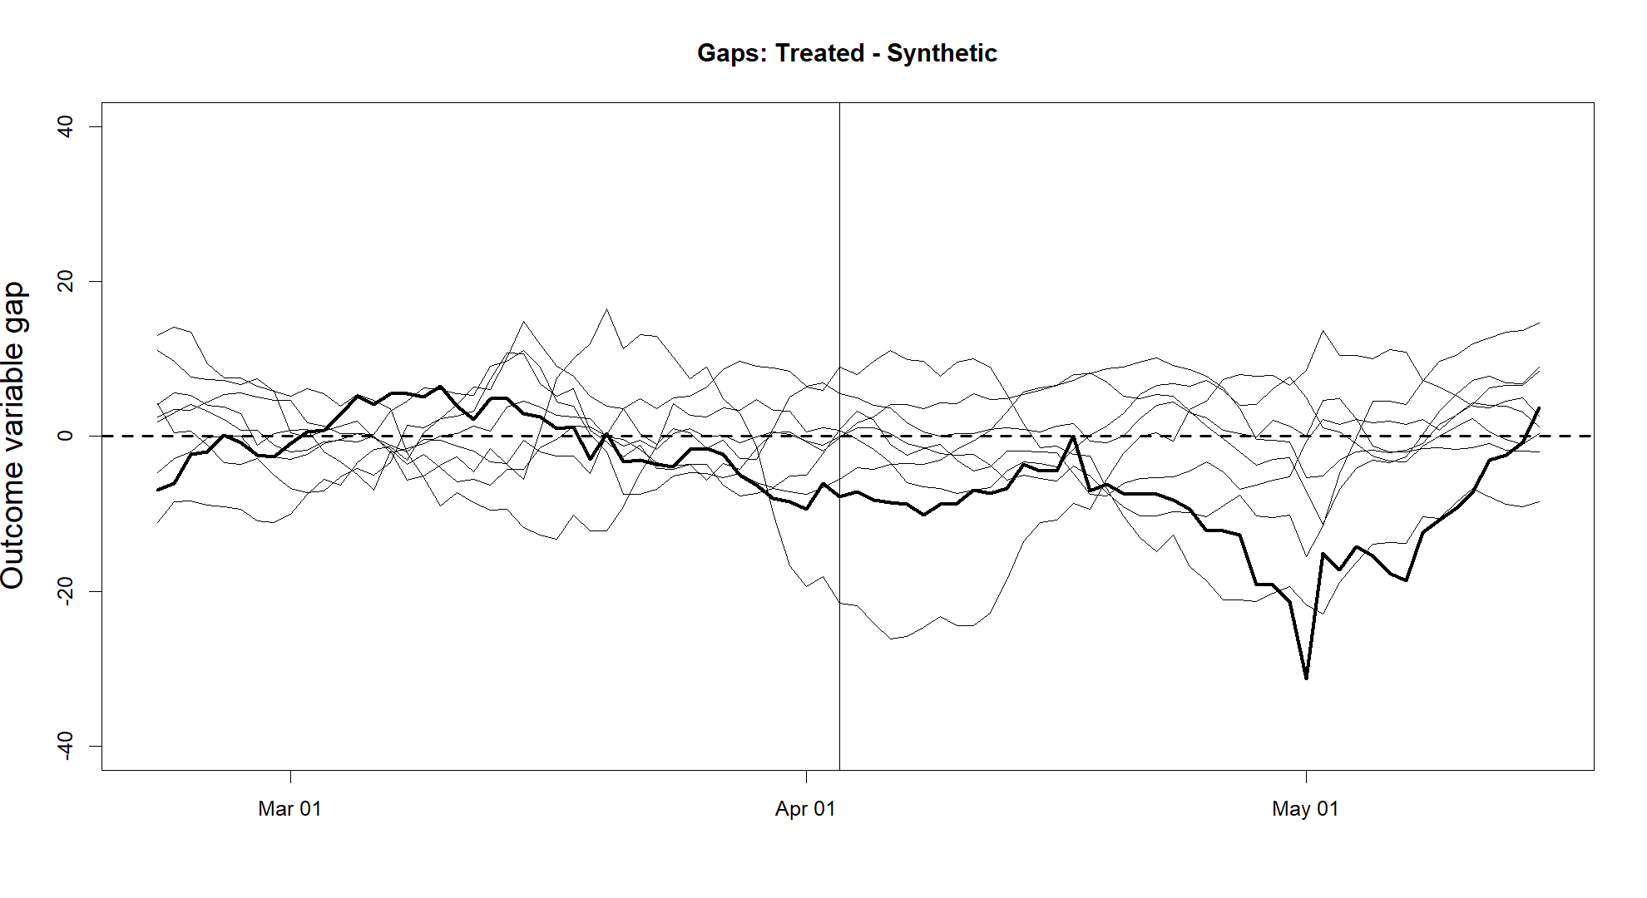
Figure 5: The dark line represents the estimated effects for Mecklenburg-Vorpommern according to equation (2) and the weights and donor units presented in table 2. Light lines represent the gaps between states in the donor pool and their synthetic versions. States with a pre-treatment MSPE of more than five times the MSPE of Mecklenburg-Vorpommern are excluded.
An alternative inferential method presented in Abadie et al. (2010) is based on comparing the post-treatment MSPE of the treated unit, the donor units, and their respective synthetic controls to the pre-treatment MSPE. Figure 6 shows the ratios of post-treatment MSPEs to pre-treatment MSPEs. Mecklenburg-Vorpommern does not solely stand out here either, with its synthetic control having only the second highest post- to pre-treatment MSPE ratio. Therefore, the outcome gap in figure 4 cannot be attributed with certainty to the effect of the Hotspot Regulation’s use on COVID case numbers.
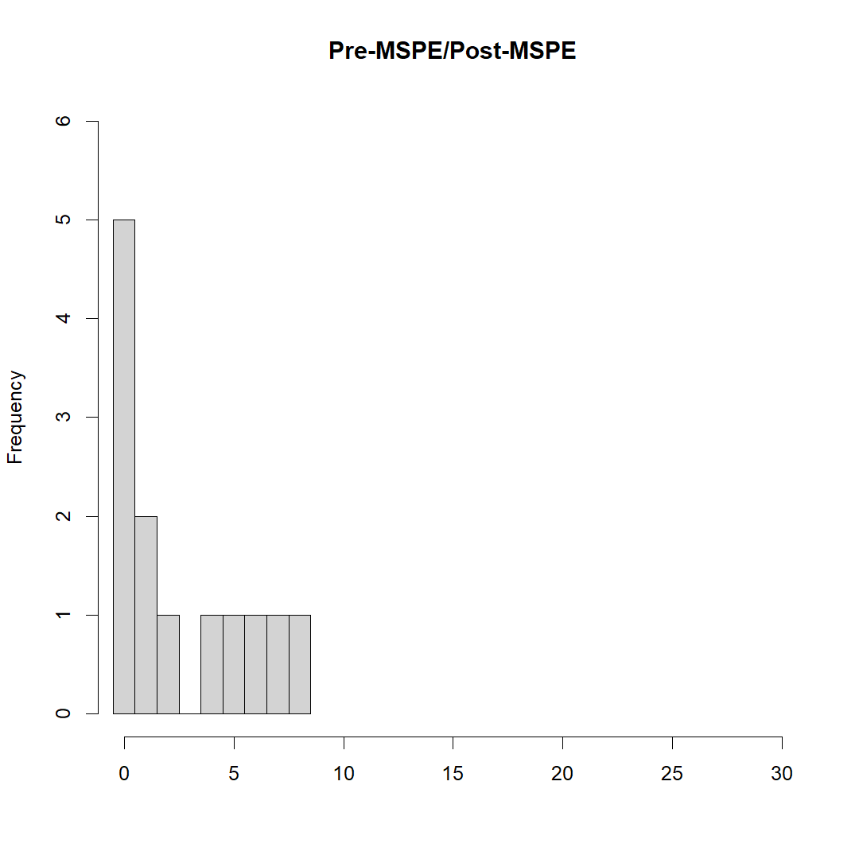
Figure 6: Ratio of post-treatment MSPE to pre-treatment MSPE of synthetic controls for all units in the selected sample, including the treated unit.

Mecklenburg-Vorpommern

It is in fact likely, that the outcome gap between Mecklenburg-Vorpommern and its synthetic control unit is implausibly large. Following Abadie et al. (2015), Figure 7 displays the result of a re-estimation of the synthetic control of Mecklenburg-Vorpommern, where iteratively one of the donor units that received a positive weight $w$ in the original estimation is left out. Recall that four states received a positive weight, so there are four leave-one-out estimates. As can be seen, omitting any of the donors does not worsen the pre-treatment fit of the synthetic control considerably. However, one of the leave one-out-estimates does not exhibit the same increase in the growth rate from mid-April to mid-May as the others. This indicates that the observed outcome gap in figures 4 and 5 is therefore mostly driven by one donor unit (Schleswig-Holstein), with its exclusion leading to a much smaller outcome gap while still maintaining a good pre-treatment fit. In fact, the ratio of post-treatment to pre-treatment MSPE of Mecklenburg-Vorpommern and its synthetic control decreases to one, when Schleswig-Holstein is omitted from the donor pool.
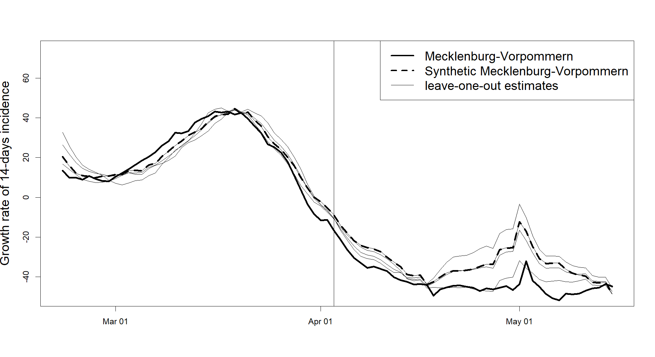
Figure 7: The leave-one-out estimates that are displayed in light lines are synthetic control estimates where a donor unit that received a positive weight in the original synthetic control estimation is iteratively omitted. The synthetic control that excludes Schleswig-Holstein from the donor pool has a different post-treatment path than the other leave-one-out estimates, suggesting that the observed post-treatment outcome gap is not robust.

A similar robustness check, iteratively omitting one of the predictors in the original estimation, shows that the presence of a good pre-treatment fit does not depend on a particular predictor either. Only the post-treatment gap shows some variation in size, depending on the weight $w$ assigned to Schleswig-Holstein (see Figure 17, top-left panel in the Appendix).

4.1.2. Hamburg
As Hamburg is both a city and a state, it is possible to choose either states or cities for the donor pool, given that data on COVID cases is also available on the municipality level. While a donor pool including all states but Hamburg and a pool including the 15 most populous German cities provide similar estimation results, the latter provides a better pre-treatment fit and is therefore presented here.
Figure 8 displays the growth rate of the 14-days COVID incidence of Hamburg and its synthetic control. The synthetic control tracks the trajectory of Hamburg’s incidence growth in the pre-treatment period closely. Following the treatment, Hamburg’s synthetic control exhibits a sharper decrease of its incidence growth rate than Hamburg for almost an entire month. Only during the first weeks of May is Hamburg’s incidence growth somewhat below its synthetic control’s growth. Conducting leave-one-out estimations, the results prove to be robust to the exclusion of donors and predictors (see figures 16 and 17, top-right panel in the Appendix).
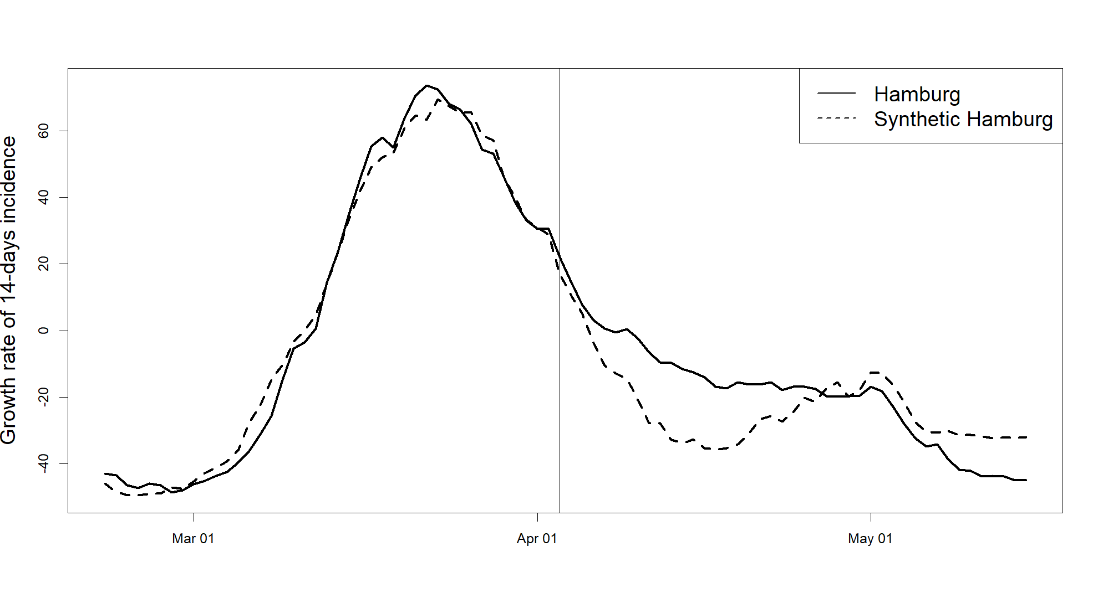
Figure 8: Comparison of the Growth rate of the 14-days COVID incidence of Hamburg to its synthetic control. The vertical line displays April 3, the day on which containment measures were lifted in 14 out of 16 German states.

Table 3 shows the predictors values of Hamburg, its synthetic control, and the sample mean. The synthetic control resembles Hamburg more than the sample mean in all predictors except for the unemployment rate, which is not assigned a positive weight $v$. Here, the largest weights are put on the population density and the ratio of the population having received a booster vaccination. Table 4 displays the donor units, with the cities of Bremen, Dortmund, Frankfurt, and Stuttgart receiving positive weights.
Table 3: Predictor values and weights
Predictor | Hamburg | Synthetic Hamburg | Sample Mean | weight $v$
Growth rate on March 6 | -36.2 | -27.7 | -17.1 | 0.038
Growth rate on March 20 | 63.9 | 60.9 | 37.5 | 0.055
Growth rate on April 3 | 22.1 | 16.9 | -1.3 | 0.001
Unemployment rate | 8.3 | 9.6 | 9.3 | 0.002
Population density | 2453 | 2458 | 2742 | 0.544
Ratio of population having received a booster vaccination | 0.635 | 0.626 | 0.772 | 0.361
Note: The predictor’s weights are chosen by minimizing equation (4). Note that the ratio of the population having received a booster vaccination might be overestimated for cities, as discussed in subsection 3.1. The sample mean refers to the mean of the selected comparison group, not including the treated unit. Growth rate refers to the growth rate of the 14-days COVID incidence.
Table 4: Weights $w$
City | Weight $w_{j}^{*}$ | City | Weight $w_{j}^{*}$
Bremen | 0.316 | Dortmund | 0.213
Düsseldorf | 0 | Frankfurt am Main | 0.464
Duisburg | 0 | Stuttgart | 0.007
Essen | 0 | Munich | 0
Wuppertal | 0 | Nuremberg | 0
Cologne | 0 | Dresden | 0
Bochum | 0 | Berlin | 0
Note: The donor unit’s weights are chosen by minimizing equation (3).

Figure 9 displays the outcome gap of Hamburg and its synthetic control, and placebo gaps of synthetic control estimations for the comparison states. Again, synthetic controls with a pre-treatment MSPE of more than five times the MSPE of the treated unit’s synthetic control are excluded. The dark line, representing the gap between Hamburg and its synthetic control, clearly contrasts the placebo gaps for most of the post-treatment period, with the same holding for a comparison of post- to pre-treatment MSPE ratios (see figure 15, top-right panel in the Appendix). However, the outcome stands out in the opposite direction of what one would expect if the additional measures in Hamburg had a negative effect on COVID cases in Hamburg. Thus, like for Mecklenburg-Vorpommern, estimating a synthetic control for the growth rate of the 14-days COVID incidence of Hamburg does not provide evidence for a significant negative effect of the additional containment measures taken.
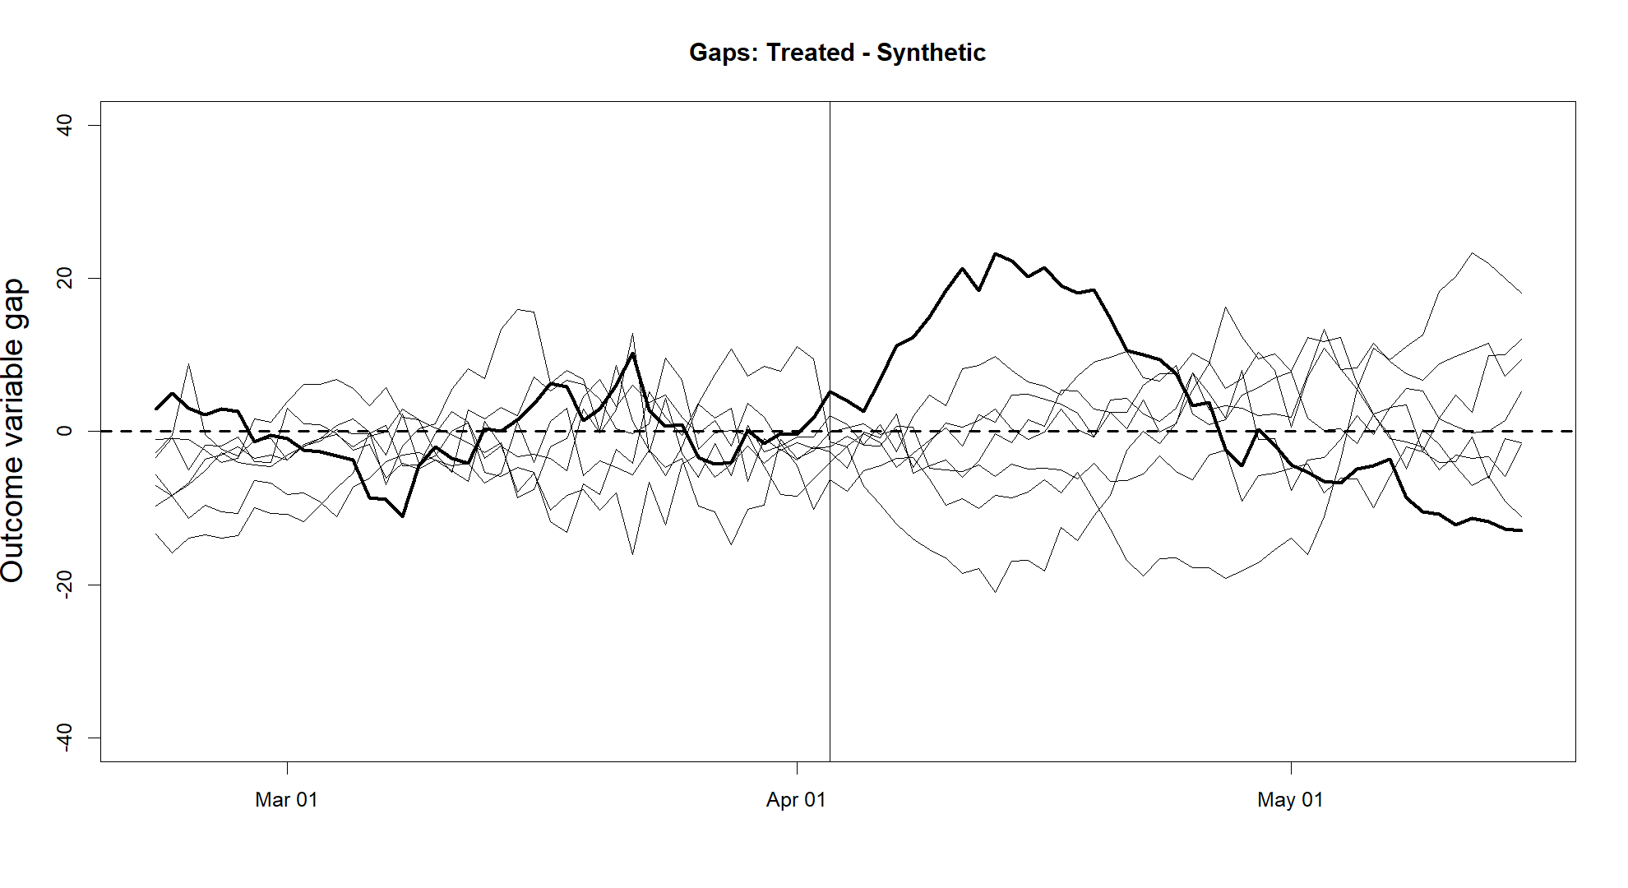
Figure 9: The dark line represents the estimated effects for Hamburg according to equation (2) and the weights and donor units presented in table 4. Light lines represent the gaps between states in the donor pool and their synthetic versions. Cities with a pre-treatment MSPE of more than five times the MSPE of Hamburg are excluded.

Hospitalizations
Next, results are presented for the hospitalization incidence. Estimating a synthetic control for Hamburg and Mecklenburg-Vorpommern here is more challenging, as the hospitalization incidences of both states follow a somewhat distinct path (see figure 2). As Mecklenburg-Vorpommern had the highest hospitalization incidence in the pre-treatment period, it can only be matched well by a synthetic control consisting of other states when using the growth rate of the hospitalization incidence as the dependent variable. Hamburg, on the other hand, experiences a sharp decline in hospitalizations in early to mid-February, that cannot be matched by other states’ growth rates. Here, only an estimation in levels provides a good fit, as they do not come with such a long time lag as growth rates, leaving the pre-treatment period (starting on February 22) unaffected by the mentioned decline.
While the estimated synthetic controls for Hamburg and Mecklenburg-Vorpommern provide a good pre-treatment fit, the results should be taken with some caution, given that both states exhibit somewhat distinct patterns in their hospitalization incidence and given that the fit relies on certain specifications of the dependent variable.

4.2.1. Mecklenburg-Vorpommern
Figure 10 displays the growth rate of the 14-days hospitalization incidence of Mecklenburg-Vorpommern and its synthetic control. The control provides a good fit in the pre-treatment period, and there is no constant outcome gap observable after April 3. Pre-treatment fit and post-treatment differences are robust to the exclusion of donors and predictors (see figures 16 and 17, the bottom-left panel in the Appendix).
Table 5: Predictor values and weights
Predictor | MV | Synthetic MV | Sample Mean | weight $v$
Growth rate on March 6 | 14.2 | 7.5 | -1.3 | 0.253
Growth rate on March 13 | 2.1 | 4.0 | 8.4 | 0.673
Growth rate on April 3 | -4.6 | 0.8 | -0.3 | 0.012
Unemployment rate | 8.3 | 6.6 | 6.1 | 0.012
Population density | 69 | 186 | 234 | 0
Ratio of population having received a booster vaccination | 0.579 | 0.544 | 0.594 | 0.050
Note: The predictor’s weights are chosen by minimizing equation (4). The sample mean refers to the mean of the selected comparison group, not including the treated unit. Growth rate refers to the growth rate of the 14-days hospitalization incidence.

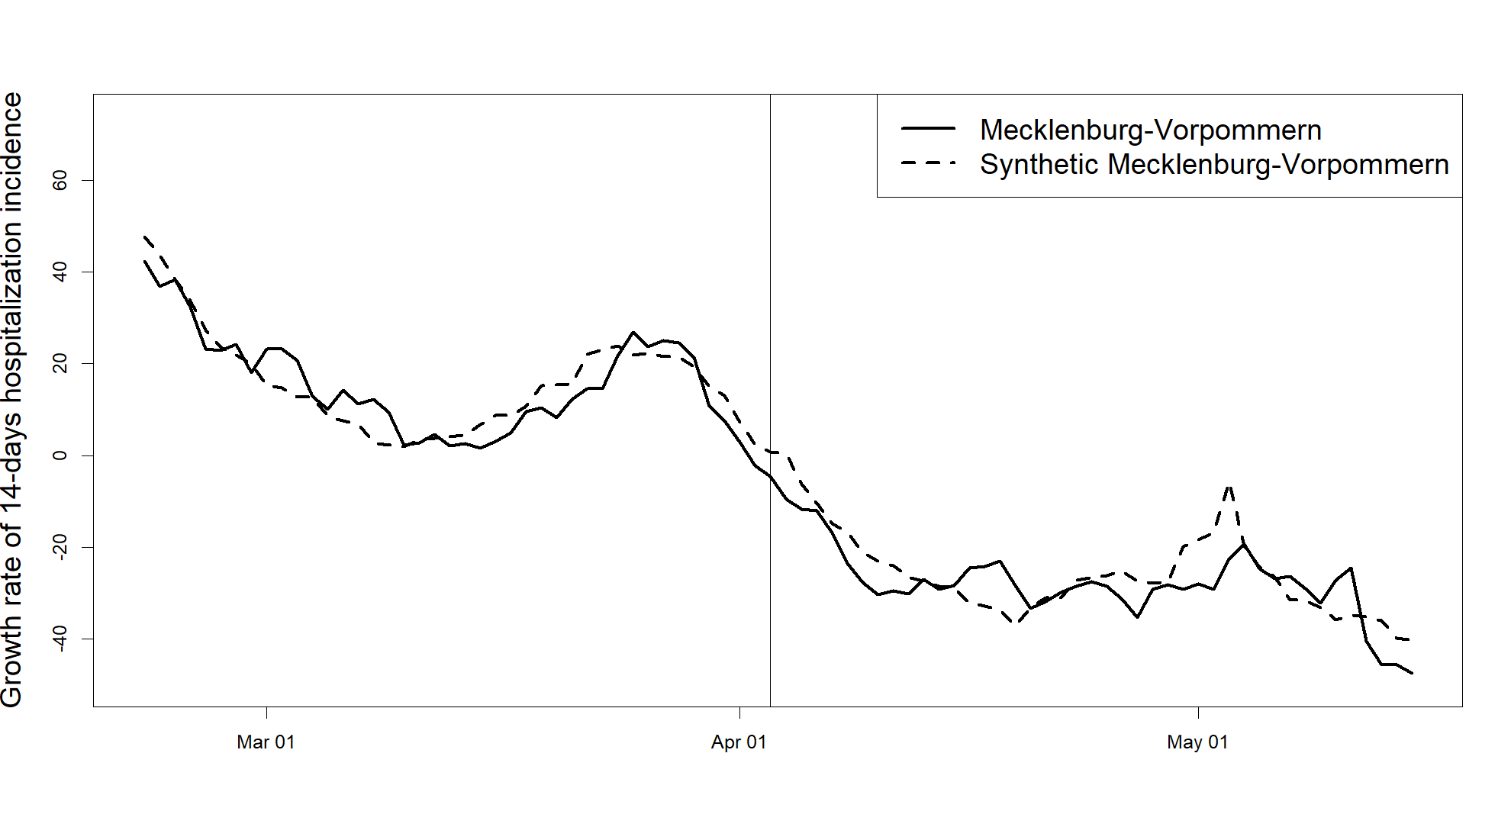
Figure 10: Comparison of the growth rate of the 14-days hospitalization incidence of Mecklenburg-Vorpommern to its synthetic control. The vertical line displays April 3, the day on which containment measures were lifted in 14 out of 16 German states.
Table 5 displays the values of key predictors for Mecklenburg-Vorpommern, its synthetic control, and the selected sample average. Again, the synthetic control is closer to the treated unit in most of the predictors’ values, with the largest weights being placed on two pre-treatment outcome variables. Table 6 displays the weights assigned to units in the donor pool, with the states of Saxony, Lower-Saxony, Saxony-Anhalt, and Thuringia receiving positive weights.
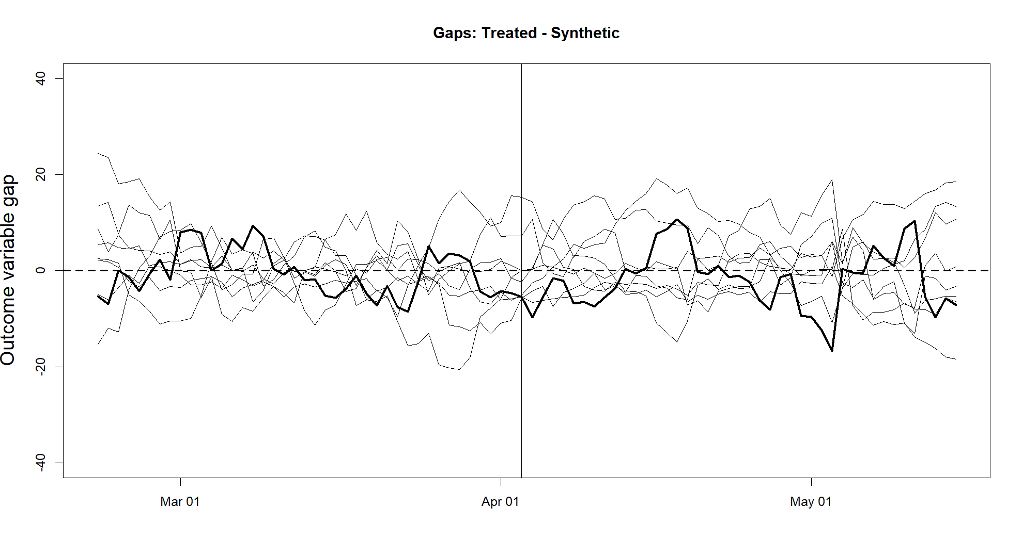
Figure 11: The dark line represents the estimated effects for Mecklenburg-Vorpommern according to equation (2) and the weights and donor units presented in table 6. Light lines represent the gaps between states in the donor pool and their synthetic versions. States with a pre-treatment MSPE of more than five times the MSPE of Mecklenburg-Vorpommern are excluded.
Table 6: Weights $w$
State | Weight $w_{j}^{*}$ | State | Weight $w_{j}^{*}$
Schleswig-Holstein | 0 | Bavaria | 0
Lower Saxony | 0.287 | Saarland | 0
North Rhine-Westphalia | 0 | Brandenburg | 0
Hesse | 0 | Saxony | 0.540
Rhineland-Palatinate | 0 | Saxony-Anhalt | 0.163
Baden-Württemberg | 0 | Thuringia | 0.010
Note: The donor unit’s weights are chosen by minimizing equation (3).

Figure 11 displays the estimated outcome gaps for the treated unit and placebo interventions, where again only placebo estimations with a pre-treatment MSPE of less than five teams the MSPE of the treated unit’s MSPE are included. Among the seven placebo-interventions incorporated, the outcome gap of Mecklenburg-Vorpommern and its synthetic control seems to show only natural variation and does not stand out. The same holds true for a comparison of post- to -pre-treatment MSPE ratios (see figure 15, bottom-left panel in the Appendix)

4.2.2. Hamburg
The fourth synthetic control estimation regards the hospitalization incidence of Hamburg. As mentioned before, no synthetic control for the growth rate of the 14-days hospitalization incidence that matches Hamburg in the pre-treatment period closely can be estimated. Hamburg experienced a distinct and sharp decline of hospitalizations in early to mid-February. As the growth rate of the 14-days incidence comes with a longer time lag, using it as a dependent variable drags this decline into the pre-treatment period used for the estimation. Therefore, the following estimation relies on levels, using the 14-days hospitalization incidence as the dependent variable instead. As the hospitalization incidence is not reported on municipality level, the donor pool here consists of all 15 other German states.
Figure 12 displays the 14-days hospitalization incidence of Hamburg and its synthetic control. The synthetic control matches Hamburg’s hospitalization incidence in the pre-treatment period closely. After April 3, the two lines follow parallel trends for two weeks before Hamburg’s hospitalization incidence rises, creating a gap for another two weeks, before the incidence returns to a lower level. This synthetic control estimation also provides no support for a significant negative effect of the Hotspot Regulation’s application, given that Hamburg’s hospitalization incidence does not fall below its synthetic control for more than one day in the post-treatment period. The result is robust to the exclusion of donor units and predictors (see figures 16 and 17, bottom-right panel in the Appendix).
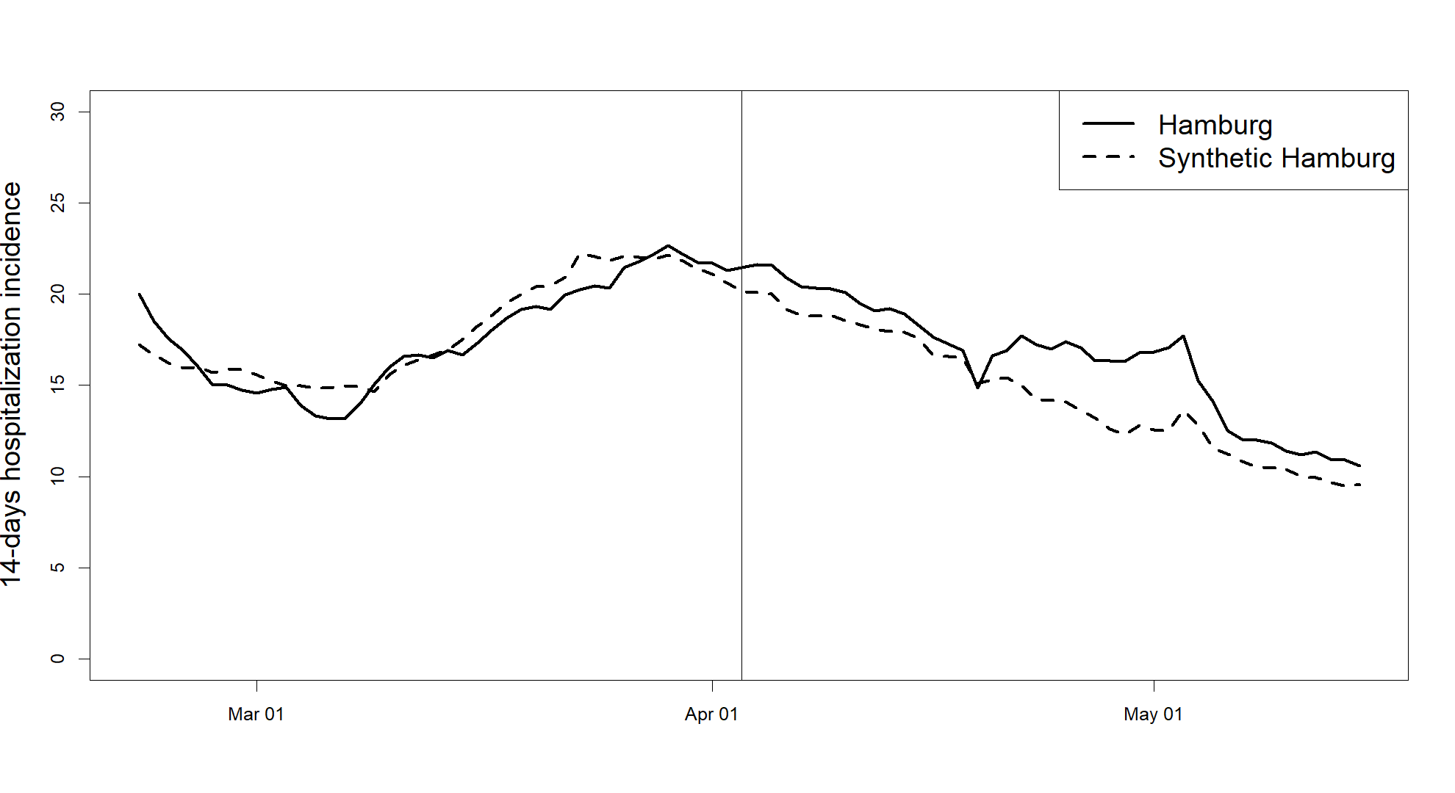
Figure 12: Comparison of the 14-days hospitalization incidence of Hamburg to its synthetic control. The vertical line displays April 3, the day on which containment measures were lifted in 14 out of 16 German states.
Table 7 and 8 display the predictors and the weights placed on the donor units. In this estimation, most predictor weight is placed on one included pre-treatment outcome: the hospitalization incidence on March 20. There are four donor units with a positive weight $w$, namely Schleswig-Holstein, Berlin, Saarland, and Bremen.
Table 7: Predictor values and weights
Predictor | Hamburg | Synthetic Hamburg | Sample Mean | weight $v$
Hospitalization incidence on March 6 | 15.0 | 15.8 | 23.2 | 0.123
Hospitalization incidence on March 20 | 19.3 | 19.6 | 28.2 | 0.579
Hospitalization incidence on April 3 | 21.5 | 20.7 | 27.6 | 0.287
Unemployment rate | 8.3 | 8.5 | 6.9 | 0.004
Population density | 2453 | 1636 | 610 | 0.005
Ratio of population having received a booster vaccination | 0.635 | 0.654 | 0.599 | 0.001
Note: The predictor’s weights are chosen by minimizing equation (4). The sample mean refers to the mean of the selected comparison group, not including the treated unit. Hospitalization incidence refers to the 14-days hospitalization incidence.
Table 8: Weights $w$
State | Weight $w_{j}^{*}$ | State | Weight $w_{j}^{*}$
Schleswig-Holstein | 0.469 | Bavaria | 0
Lower Saxony | 0 | Saarland | 0.117
North Rhine-Westphalia | 0 | Brandenburg | 0
Hesse | 0 | Saxony | 0
Rhineland-Palatinate | 0 | Saxony-Anhalt | 0
Baden-Württemberg | 0 | Thuringia | 0
Berlin | 0.336 | Bremen | 0.077
Note: The donor unit’s weights are chosen by minimizing equation (3).

4.3. A Possible Control of Spillover Effects
So far, none of the preceding results have provided much support for the presence of a notable effect of the additional containment measures in Hamburg and Mecklenburg-Vorpommern on COVID cases or hospitalizations in these states. A skeptical reader might point out that the presented results underestimate the effect of the Hotspot Regulation due to the presence of spillover effects. Spillover effects, as discussed in Abadie (2021), occur when a treatment also has an effect on the outcome variable of units not targeted by it. In this context, the opposite way (untreated units affecting the treated unit) might be just as relevant. As the coronavirus easily crosses state borders, due to commuters or shoppers for example, one can expect an initially different COVID incidence of two neighboring states to align. Therefore, if the use of the Hotspot Regulation drove down in-state infections significantly, we might not be observing this effect due to spillover effects.
Given the specific context presented here, this is a limitation of this study. However, there is one estimation setting with which it might be possible to partly address this concern. Data on COVID cases is not only available on a federal and state level, but also on a county level. Therefore, it is possible to aggregate counties affected by the treatment that do not share a border with any other state to form a new treated unit, which, given the increased physical distance, might be less affected by interference across units.
In Figure 13, I am presenting such an estimation for the aggregated cities Schwerin and Rostock. Both are city municipalities (kreisfreie Städte) in Mecklenburg-Vorpommern that are “landlocked” in Mecklenburg-Vorpommern. From Schwerin, it takes almost an hour by car to reach the closest towns outside the state, while it takes even longer from Rostock. One could hypothesize that should the Hotspot Regulation have had a noticeable effect, it should be more prominently visible in this setting, as spillover effects might be less of a concern here.
Figure 13 presents the estimated synthetic control, and figure 14 the placebo tests (tables 9 and 10 in the Appendix contain predictors and weights $w$. As a comparison group, city municipalities from the neighboring states of Schleswig-Holstein, Lower-Saxony, Brandenburg, and Saxony-Anhalt are chosen. However, the results are not as promising as anticipated. While there is a notable outcome gap visible in figure 13, the placebo gaps in figure 14 show substantial spreads up to 40 percentage points in the post-treatment period, undermining the confidence that a synthetic control can reproduce the outcome path of a unit in the absence of an intervention here. Therefore, it is not possible to distinguish a gap that was created by pure chance from a gap driven by an actual effect in the absence of spillover effects – there is just too much variation.
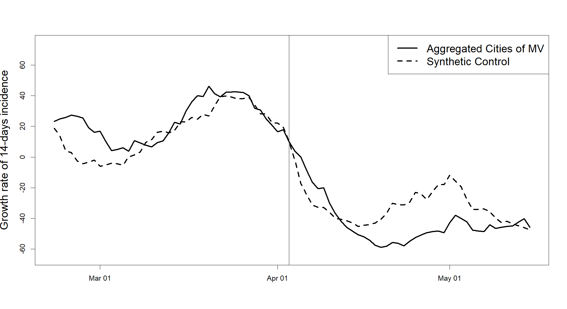
Figure 13: Comparison of the growth rate of the 14-days COVID incidence of combined Schwerin and Rostock to the synthetic control. The vertical line displays April 3, the day on which containment measures were lifted in 14 out of 16 German states.
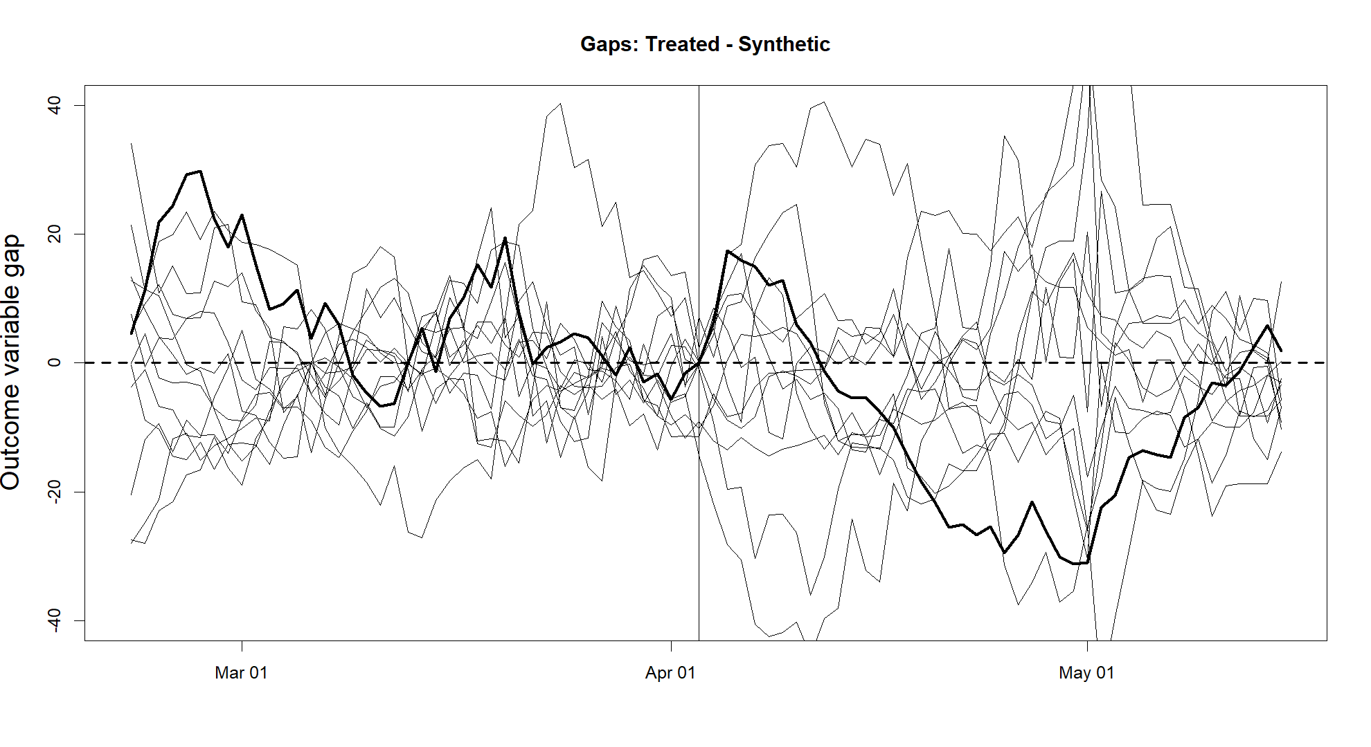
Figure 14: The dark line represents the estimated effects. Light lines represent the gaps between cities in the donor pool and their synthetic versions. States with a pre-treatment MSPE of more than five times the MSPE of the original estimation are excluded.

Concluding Remarks
This study evaluated a natural experiment with the synthetic control method to estimate the effects of additional COVID-19 restrictions in the German states of Hamburg and Mecklenburg-Vorpommern in April 2022. The results show no significant reduction of the spread of COVID-19 and the number of infected patients hospitalized in these states. Several robustness checks have been conducted, including changes to the predictors, donor units, dependent variables, date of intervention, and post-treatment period, with no relevant changes to the findings.
This raises the question of how the results presented above can be reconciled with the broad evidence, presented in Howard et al. (2021) and Brooks and Butler (2021) for example, finding mask wearing to be effective to reduce the spread of COVID-19 infections. Several things should be noted: Firstly, this study does not evaluate the effects of mask wearing itself, but the effects of a policy mandating mask wearing in certain areas as well as proofs of vaccination or testing for entering certain facilities. This makes an important difference: for the evaluation of the Hotspot Regulation, it suffices for the comparison group to not have the same measures in place. This does not indicate however, that people in the other 14 states did not wear masks after April 3 or did not test themselves. In fact, they might have voluntarily kept precautions that were just not mandatory anymore.
Secondly, the relatively short period until the end of the natural experiment might be responsible for the absence of observable effects. COVID-19 cases display an exponential growth pattern, consequently it might have taken more time for vaster differences to emerge, especially if people in comparison states dropped precautions only slowly after the expiration of measures. Thirdly, spillover effects might have played a role, leading to the possible underestimation of an effect. However, it is unlikely that spillover effects alone disguise an effect of greater magnitude in this setting. And finally, with the placebo gaps of growth rates being as wide as 20 percentage points, the data also displays a substantial amount of noise, making it hard to disentangle smaller effects from results that might have been produced by chance.
To sum up, the absence of an effect in the presented results indicate that the application of the Hotspot Regulation in Hamburg and Mecklenburg-Vorpommern did not have a substantial effect on COVID-19 infections and hospitalizations, but small effects cannot be ruled out. Still, this calls into question the efficacy of the Hotspot Regulation as a measure to break extraordinary infection waves and has important implications for policymakers and public health officials, should they consider reintroducing similar containment measures.

- Publication bibliography
Abadie, Alberto (2021): Using Synthetic Controls: Feasibility, Data Requirements, and Methodological Aspects. In Journal of Economic Literature 59 (2), pp. 391–425. DOI: 10.1257/jel.20191450.
Abadie, Alberto; Diamond, Alexis; Hainmueller, Jens (2010): Synthetic Control Methods for Comparative Case Studies: Estimating the Effect of California’s Tobacco Control Program. In Journal of the American Statistical Association 105 (490), pp. 493–505. DOI: 10.1198/jasa.2009.ap08746.
Abadie, Alberto; Diamond, Alexis; Hainmueller, Jens (2011): Synth : An R Package for Synthetic Control Methods in Comparative Case Studies. In J. Stat. Soft. 42 (13). DOI: 10.18637/jss.v042.i13.
Abadie, Alberto; Diamond, Alexis; Hainmueller, Jens (2015): Comparative Politics and the Synthetic Control Method. In American Journal of Political Science 59 (2), pp. 495–510. DOI: 10.1111/ajps.12116.
Abadie, Alberto; Gardeazabal, Javier (2003): The Economic Costs of Conflict: A Case Study of the Basque Country. In American Economic Review 93 (1), pp. 113–132. DOI: 10.1257/000282803321455188.
Athey, Susan; Imbens, Guido W. (2017): The State of Applied Econometrics: Causality and Policy Evaluation. In Journal of Economic Perspectives 31 (2), pp. 3–32. DOI: 10.1257/jep.31.2.3.
Bingener, Reinhard; Burger, Reiner (2022): Nur zwei Länder wenden die Hotspot-Regel an. In Frankfurter Allgemeine Zeitung, 3/29/2022. Available online at https://www.faz.net/aktuell/politik/inland/nur-hamburg-und-mecklenburg-vorpommern-wenden-hotspot-regel-an-17919476.html, checked on 4/30/2022.
Brooks, John T.; Butler, Jay C. (2021): Effectiveness of Mask Wearing to Control Community Spread of SARS-CoV-2. In JAMA 325 (10), pp. 998–999. DOI: 10.1001/jama.2021.1505.
Bundesgesetzblatt (2022): Gesetz zur Änderung des Infektionsschutzgesetzes und anderer Vorschriften (10), 3/18/2022.
Burger, Reiner; Locke, Stefan; Wyssuwa, Matthias (2022): Es ist so schwer, ein Hotspot zu sein. In Frankfurter Allgemeine Zeitung, 3/30/2022. Available online at https://www.faz.net/aktuell/politik/inland/corona-hotspots-laender-halten-neue-regelung-fuer-kaum-anwendbar-17922305.html?premium, checked on 4/30/2022.
Busche, Laureen (2022): Warum die Hotspot-Regelung wenig genutzt wird. In Panorama, 1/4/2022. Available online at https://www.zdf.de/nachrichten/panorama/corona-hotspot-regeln-anwendung-100.html, checked on 1/26/2023.
Cunningham, Scott (2021): Causal Inference The Mixtape. New Haven, London: Yale University Press. Available online at https://mixtape.scunning.com/10-synthetic_control, checked on 1/26/2023.
Cunningham, Scott; Shah, Manisha (2018): Decriminalizing Indoor Prostitution: Implications for Sexual Violence and Public Health. In Rev Econ Stud 85 (3), pp. 1683–1715. DOI: 10.1093/restud/rdx065.
Gemeinsames Statistikportal des Bundes und der Länder (2021): Arbeitslose nach ausgewählten Personengruppen sowie Arbeitslosenquoten - Jahresdurchschnitt - (ab 2009) regionale Tiefe: Kreise und krfr. Städte. Available online at https://www.regionalstatistik.de/genesis/online?operation=table&code=13211-02-05-4&bypass=true&levelindex=0&levelid=1667951666331#abreadcrumb, updated on 1/15/2023, checked on 1/15/2023.
Gemeinsames Statistikportal des Bundes und der Länder (2022): Volkswirtschaftliche Gesamtrechnungen der Länder. Available online at https://www.statistikportal.de/sites/default/files/2022-06/vgrdl_faltblatt_bs2021.pdf, checked on 1/23/2023.
Howard, Jeremy; Huang, Austin; Li, Zhiyuan; Tufekci, Zeynep; Zdimal, Vladimir; van der Westhuizen, Helene-Mari et al. (2021): An evidence review of face masks against COVID-19. In Proceedings of the National Academy of Sciences of the United States of America 118 (4), e2014564118. DOI: 10.1073/pnas.2014564118.
Ministerium für Soziales, Gesundheit und Sport (2022): Landesregierung beschließt neue Corona-Landesverordnung. Available online at https://www.regierung-mv.de/Aktuell/?id=179308&processor=processor.sa.pressemitteilung, updated on 1/9/2023, checked on 1/9/2023.
NDR (2022): Gericht kippt Corona-Hotspot-Regel in MV: Das gilt jetzt. In NDR, 4/23/2022. Available online at https://www.ndr.de/nachrichten/mecklenburg-vorpommern/Gericht-kippt-Corona-Hotspot-Regel-in-MV-Das-gilt-jetzt,coronavirus6634.html, checked on 1/9/2023.
Robert Koch Institut (2022a): COVID-19 Data Hub. Available online at https://npgeo-corona-npgeo-de.hub.arcgis.com/datasets/6d78eb3b86ad4466a8e264aa2e32a2e4_0/about, checked on 9/1/2022.
Robert Koch Institut (2022b): COVID-19 Impfungen in Deutschland. Available online at https://github.com/robert-koch-institut/COVID-19-Impfungen_in_Deutschland, checked on 10/16/2022.
Robert Koch Institut (2022c): Covid-19-Hospitalisierungen in Deutschland. Available online at https://github.com/robert-koch-institut/COVID-19-Hospitalisierungen_in_Deutschland, checked on 12/17/2022.
Sozialbehörde der Stadt Hamburg (2022a): 29.04.22 Aktuelle Verordnung zur Eindämmung des Coronavirus. Available online at https://web.archive.org/web/20220430064802/https://www.hamburg.de/verordnung/, updated on 1/9/2023, checked on 1/9/2023.
Sozialbehörde der Stadt Hamburg (2022b): 31.03.22 Aktuelle Verordnung zur Eindämmung des Coronavirus. Available online at https://web.archive.org/web/20220423072052/https://www.hamburg.de/verordnung/, updated on 1/9/2023, checked on 1/9/2023.
Statistisches Bundesamt (2022): Kreisfreie Städte und Landkreise nach Fläche, Bevölkerung und Bevölkerungsdichte am 31.12.2021. Available online at https://www.destatis.de/DE/Themen/Laender-Regionen/Regionales/Gemeindeverzeichnis/Administrativ/04-kreise.html, checked on 7/7/2022.

Appendix
This Appendix provides additional figures and tables. Figure 15 shows the comparison of the ratios of all post- to pre-treatment MSPEs for the settings in subsections 4.1. and 4.2. Figure 16 and figure 17 show the leave-one-out robustness checks regarding donor units and predictors. Figure 18 shows the placebo gaps corresponding to subsection 4.2.2, whereas tables 9 and 10 correspond to subsection 4.3.
  Mecklenburg-Vorpommern | 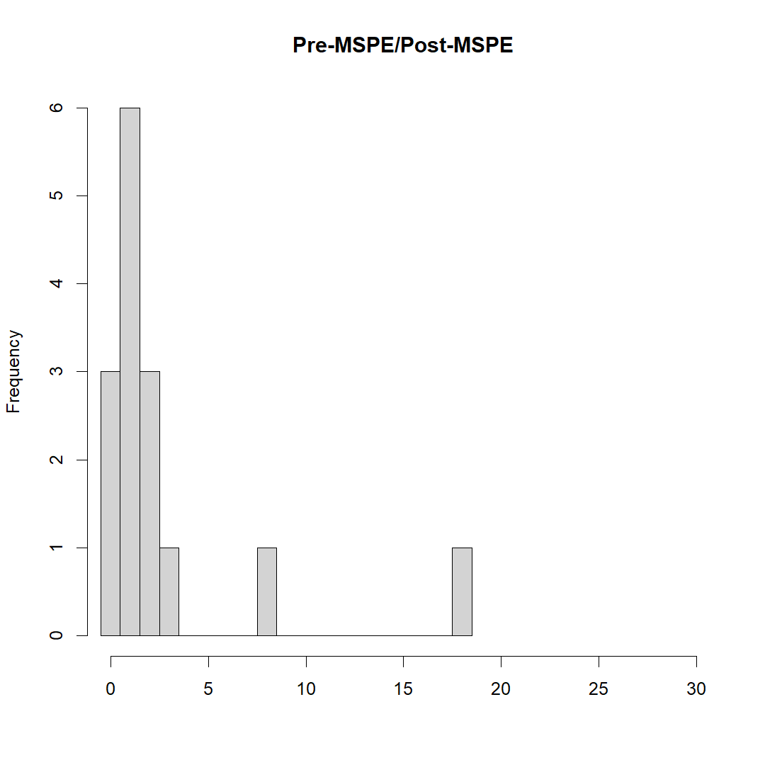  Hamburg
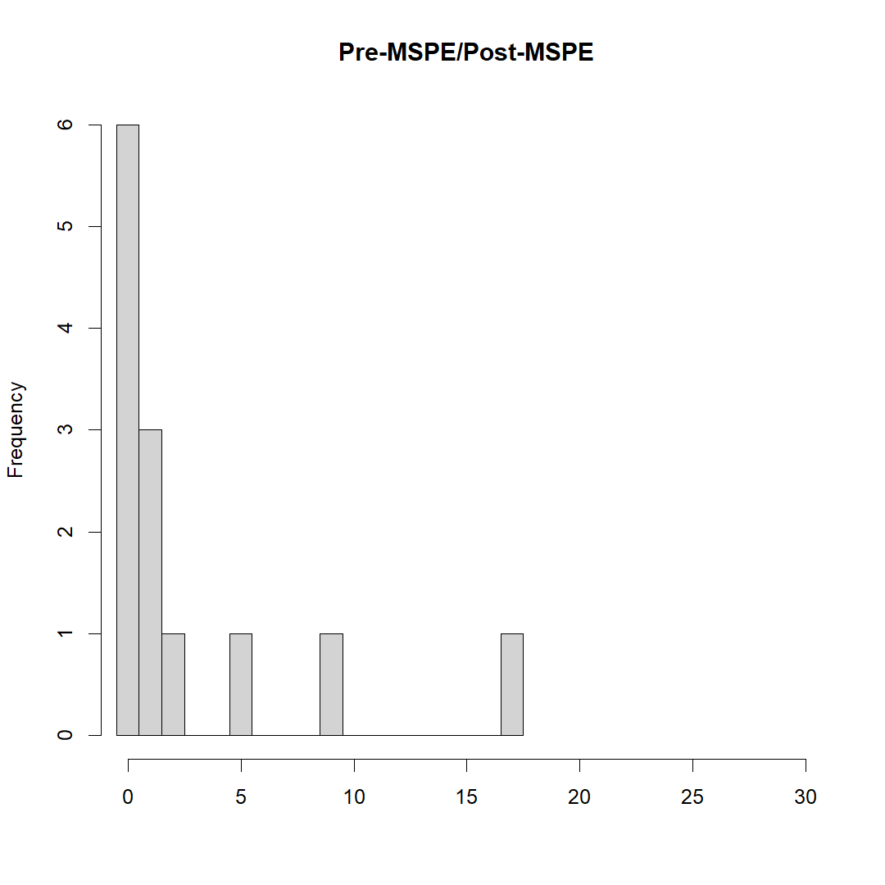  Mecklenburg-Vorpommern | 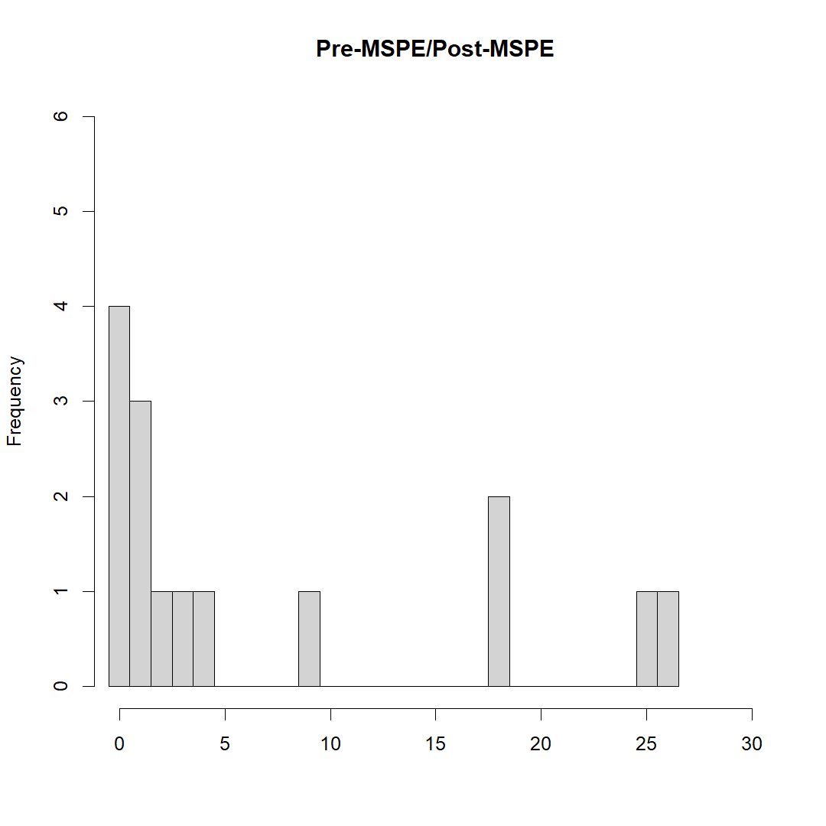  Hamburg
Figure 15: Ratio of post-treatment MSPE to pre-treatment MSPE of synthetic controls for all units in the selected sample, including the treated unit. The top-left panel corresponds to the setting in subsection 4.1.1., the top-right section to 4.1.2., bottom-left to 4.2.1., and bottom-right to 4.2.2.
 | 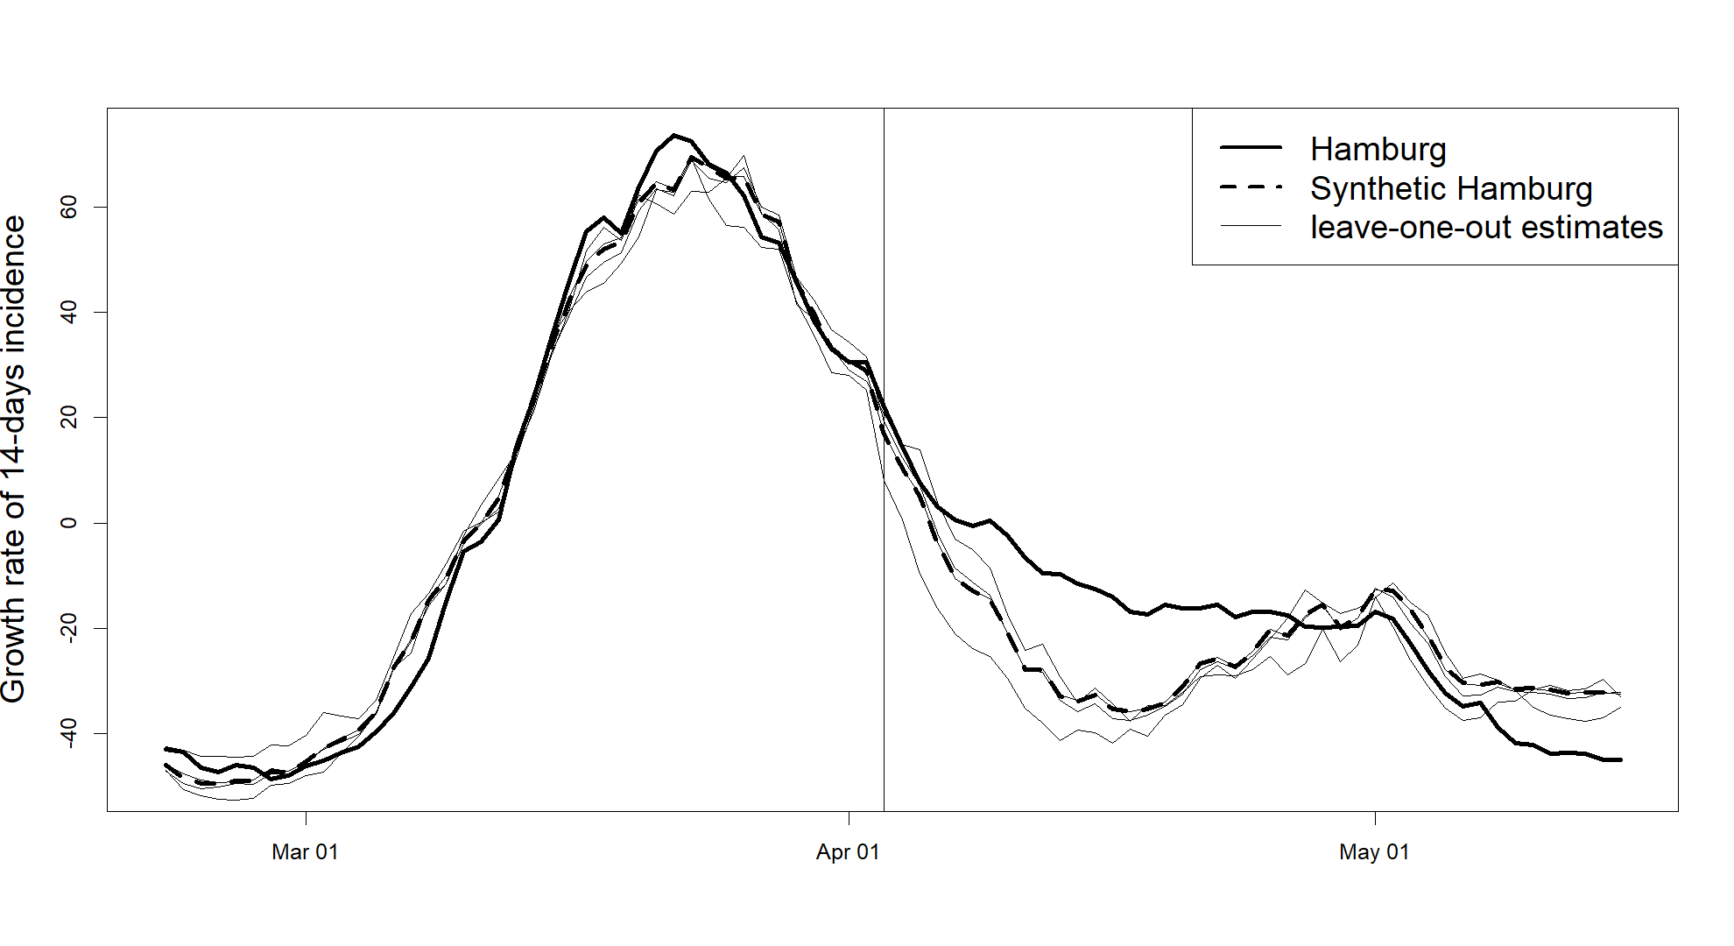
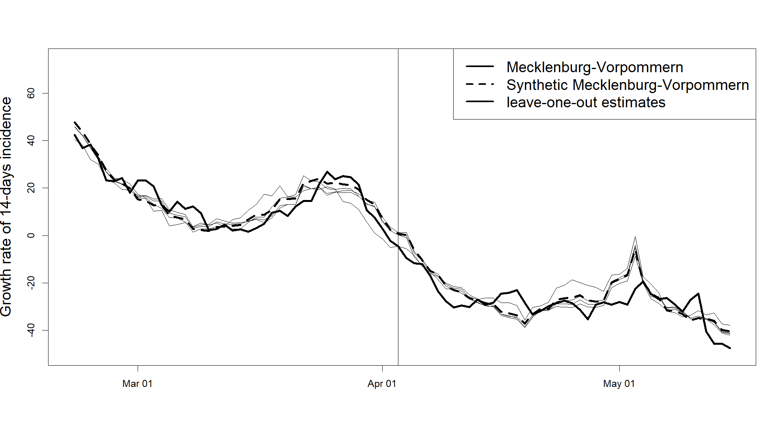 | 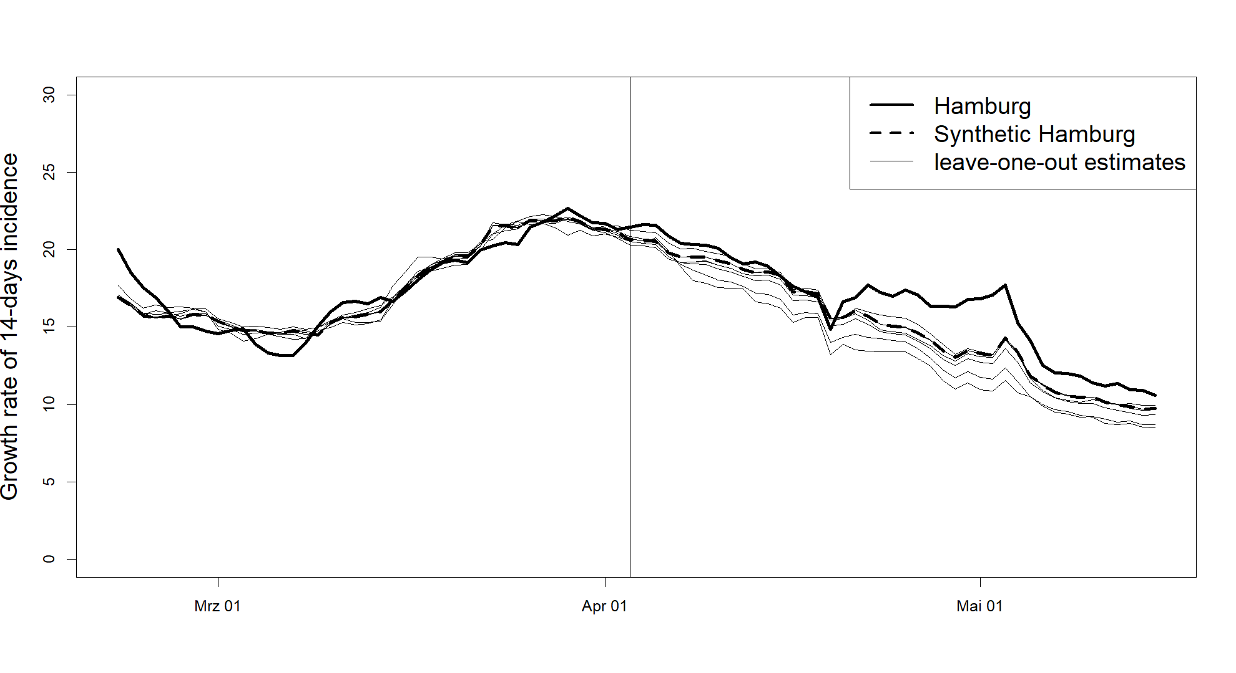
Figure 16: Leave-one-out estimates iteratively omitting a unit from the donor pool that received a positive weight $w$ in the respective original estimation. The top-left panel corresponds to subsection 4.1.1., the top-right section to 4.1.2., bottom-left to 4.2.1., and bottom-right to 4.2.2.

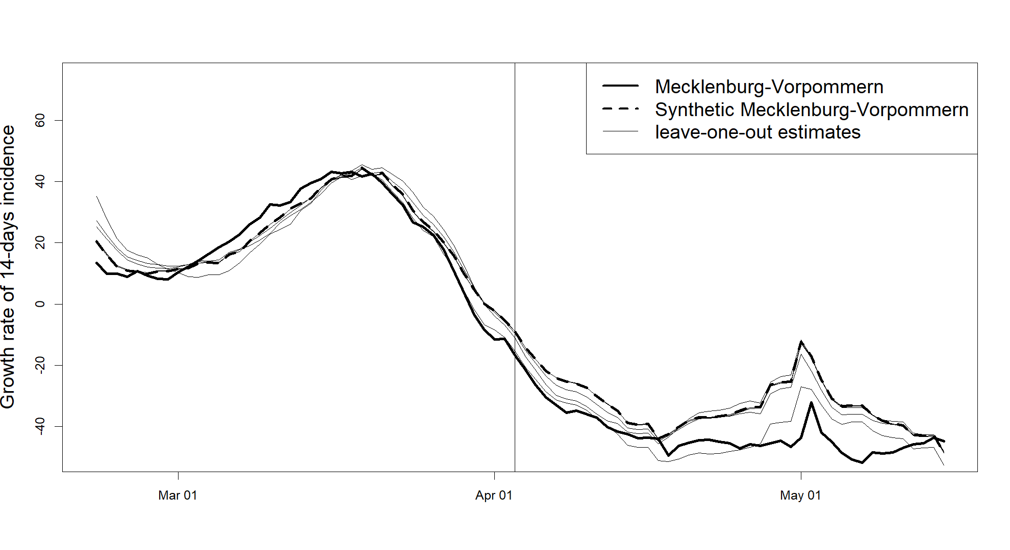 | 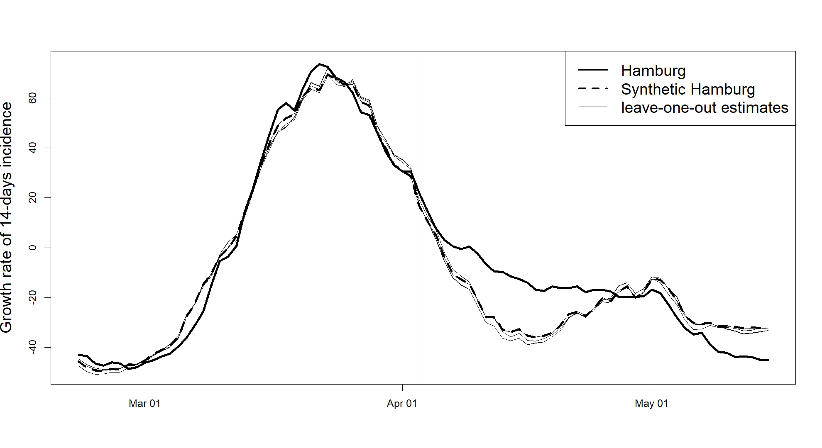
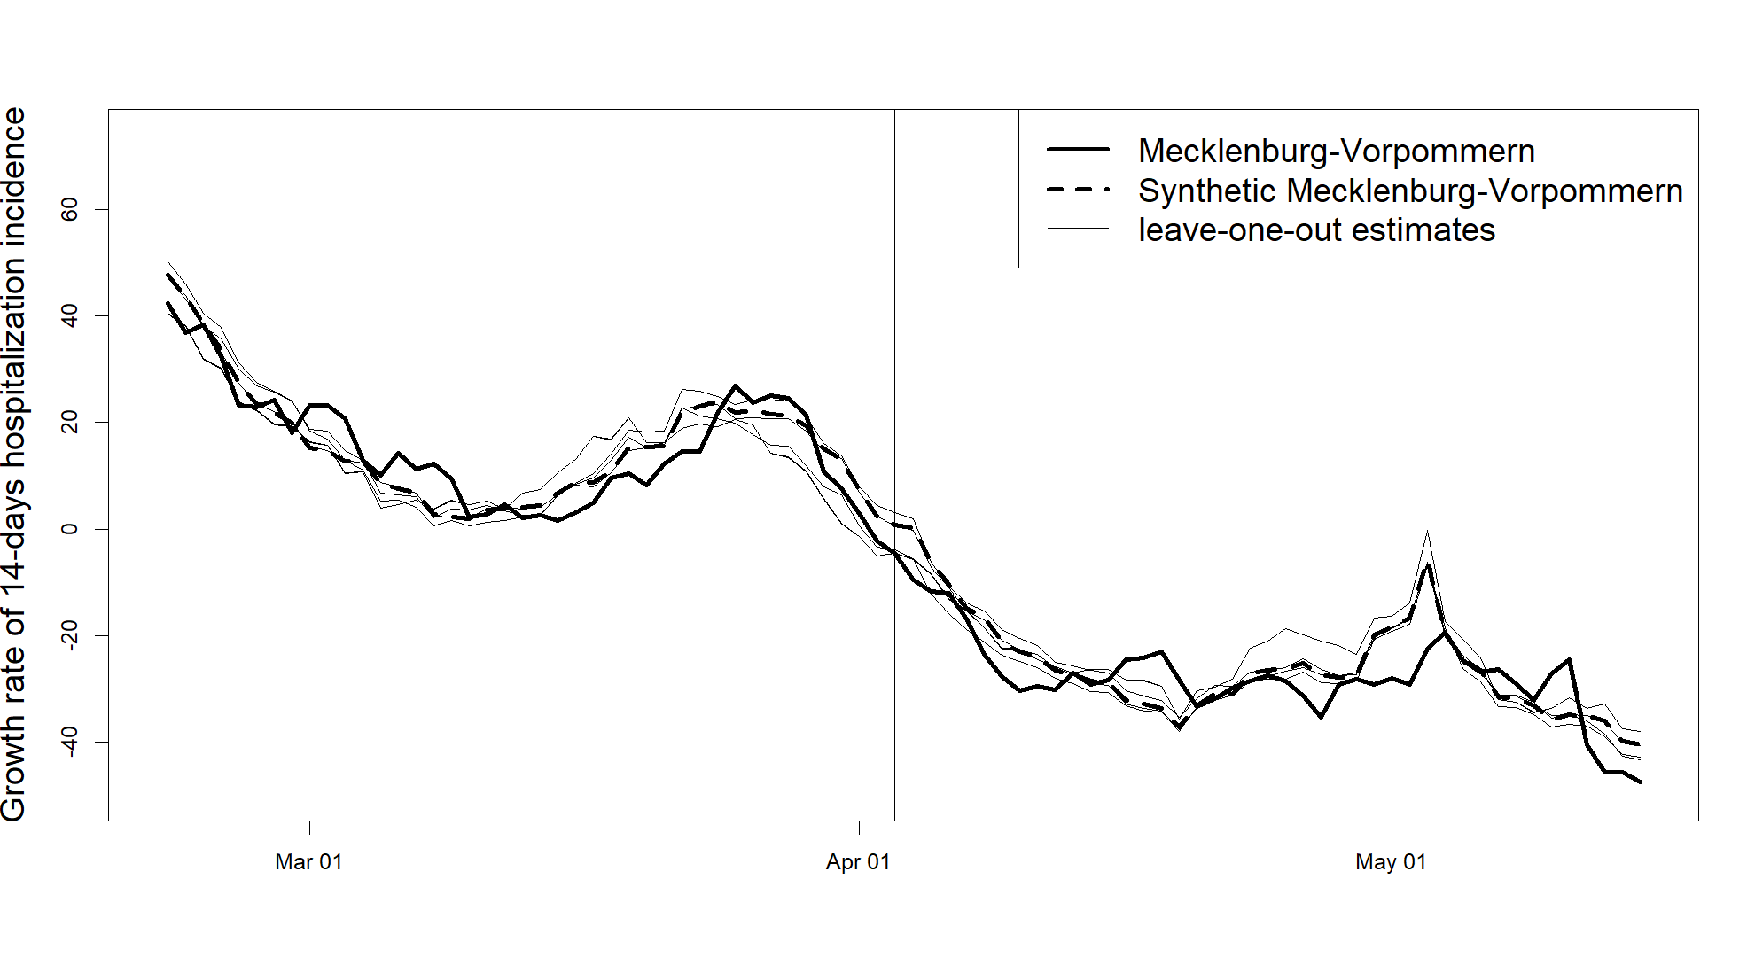 | 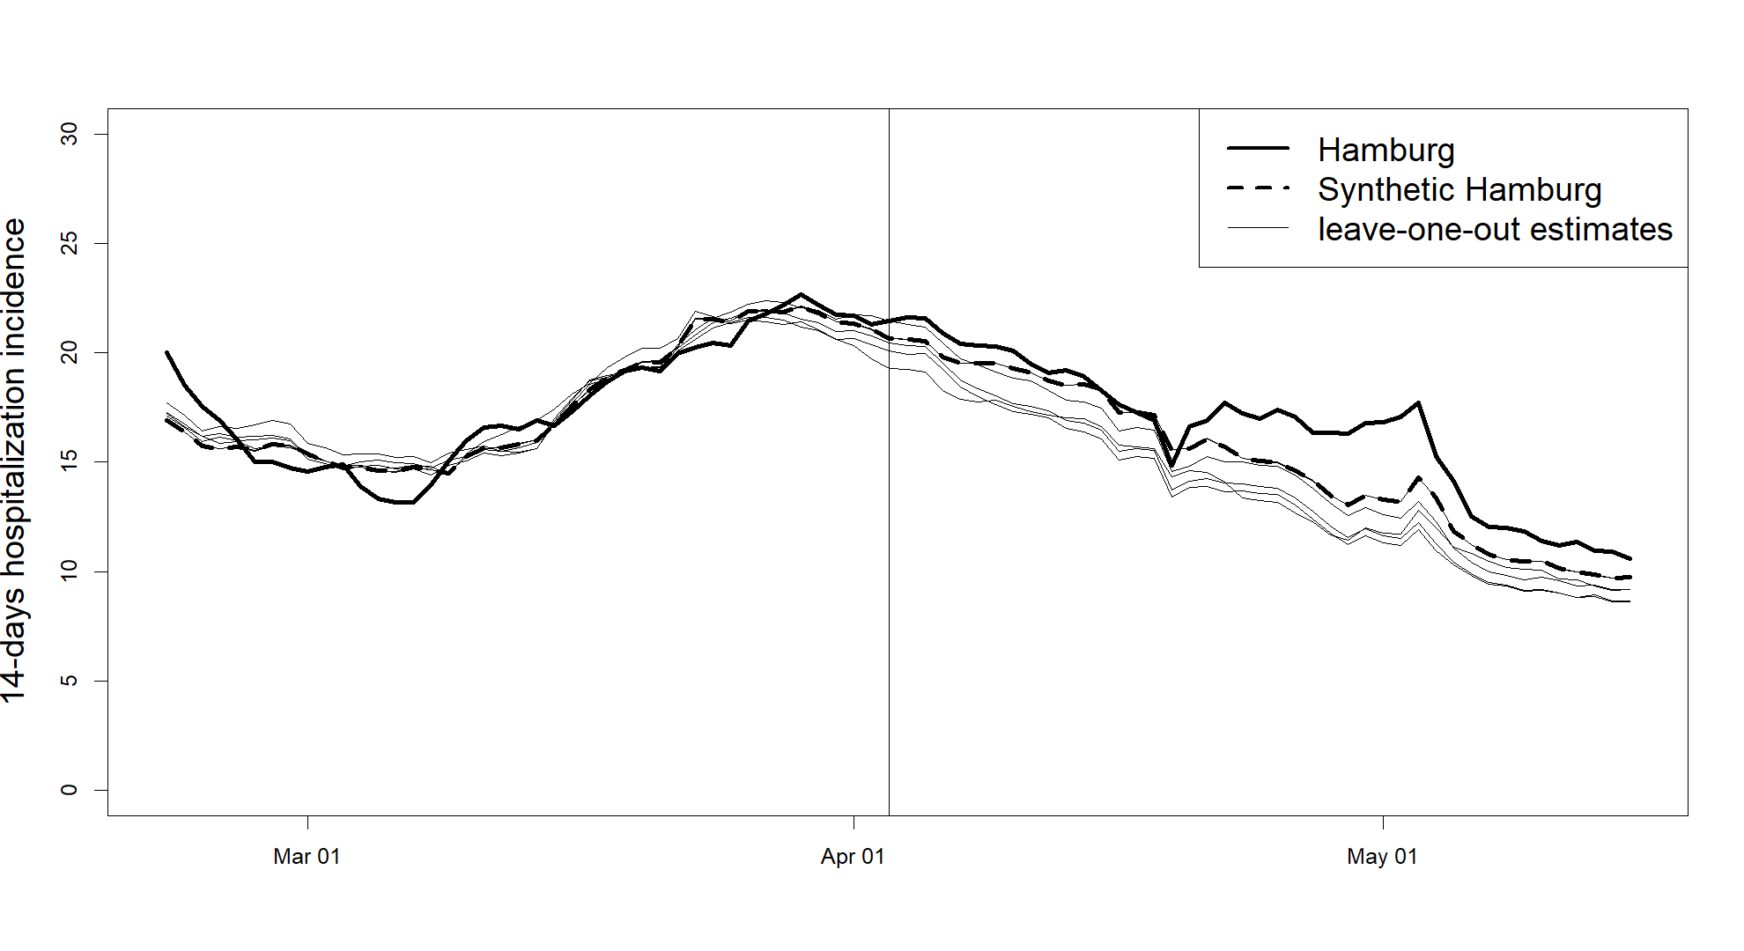
Figure 17: Leave-one-out estimates iteratively omitting a predictor that received a positive weight $v$ in the respective original estimation. The top-left panel corresponds to subsection 4.1.1., the top-right section to 4.1.2., bottom-left to 4.2.1., and bottom-right to 4.2.2.

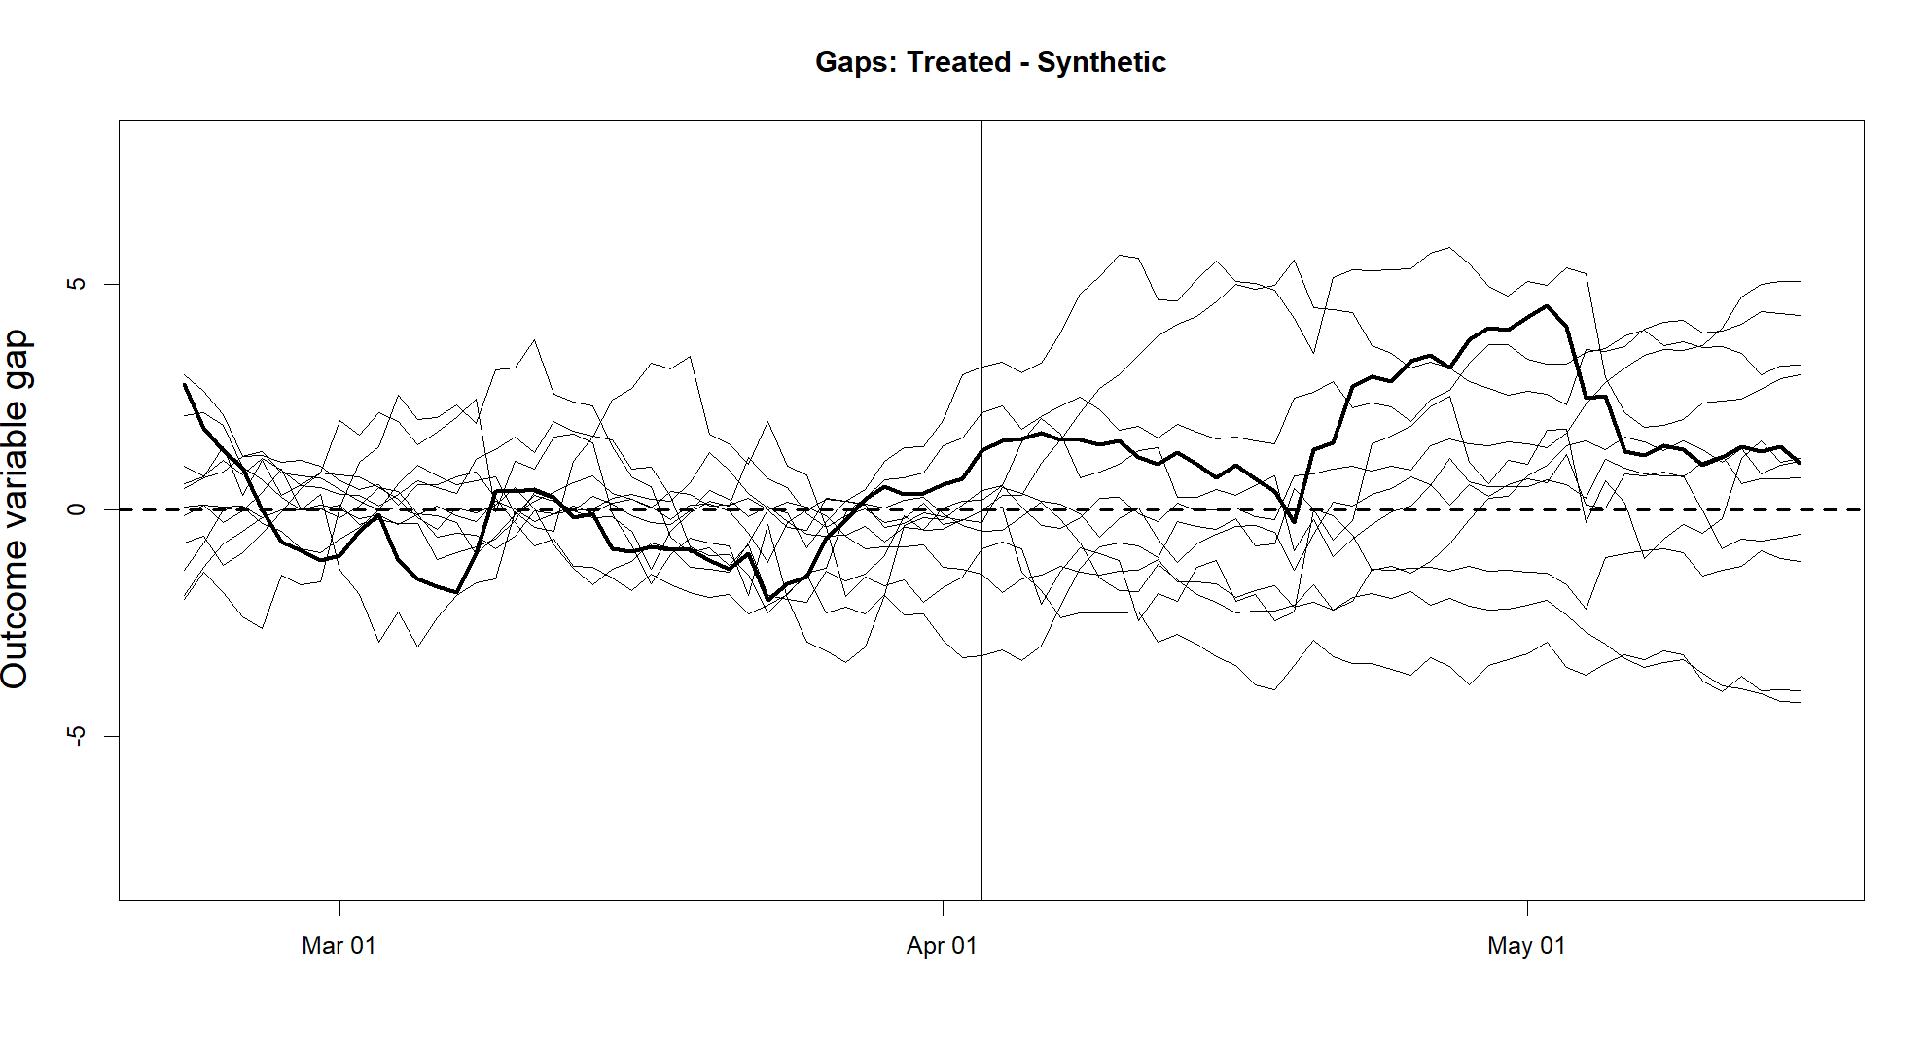
Figure 18: The dark line represents the estimated effects for Hamburg according to equation (2) and the weights and donor units presented in table 8, referring to the setting presented in section 4.2.2. Light lines represent the gaps between states in the donor pool and their synthetic versions. States with a pre-treatment MSPE of more than five times the MSPE of Hamburg are excluded.

Table 9: Predictor values and weights
Predictor | Treated | Synthetic | Sample Mean | weight $v$
Growth rate on March 6 | 3.9 | 0.2 | 7.7 | 0.004
Growth rate on March 13 | 15.8 | 15.8 | 18.9 | 0.507
Growth rate on April 3 | 10.1 | 10.0 | 9.7 | 0.188
Unemployment rate | 8.7 | 8.4 | 8.6 | 0
Population density | 977 | 978 | 1004 | 0.283
Ratio of population having received a booster vaccination | 0.640 | 0.658 | 0.769 | 0.018
Note: The predictor’s weights are chosen by minimizing equation (4). The aggregated cities of Schwerin and Rostock make up the treated unit. City municipalities in Schleswig-Holstein, Lower-Saxony, Brandenburg, and Saxony-Anhalt make up the donor pool. Growth rate refers to the growth rate of the 14-days COVID incidence.
Table 10: Weights $w$
City Municipalities | Weight $w_{j}^{*}$ | City Municipalities | Weight $w_{j}^{*}$
Flensburg | 0 | Osnabrück | 0
Kiel | 0 | Wilhelmshaven | 0
Lübeck | 0 | Brandenburg a.d.Havel | 0
Neumünster | 0 | Cottbus | 0
Braunschweig | 0.208 | Frankfurt (Oder) | 0
Salzgitter | 0 | Potsdam | 0
Wolfsburg | 0 | Dessau-Roßlau | 0.290
Delmenhorst | 0 | Halle | 0.289
Emden | 0.198 | Magdeburg | 0.015
Oldenburg | 0
Note: The donor unit’s weights are chosen by minimizing equation (3). The sample mean refers to the mean of the selected comparison group, not including the treated unit.

Affidavit
I affirm that this Bachelor thesis was written by myself without any unauthorized third-party support. All used references and resources are clearly indicated. All quotes and citations are properly referenced. This thesis was never presented in the past in the same or similar form to any examination board. I agree that my thesis may be subject to electronic plagiarism check. For this purpose, an anonymous copy may be distributed and uploaded to servers within and outside the University of Mannheim.
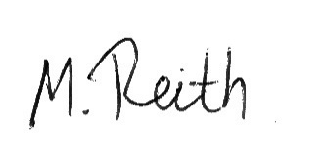
Mannheim, January 30

Calculated as COVID cases per 100,000 inhabitants within the last seven-days or, respectively, hospitalized COVID cases within the last seven days per 100,000 inhabitants.
Defined as the percentage change of the 14-days incidence compared to the 14-days incidence two weeks ago.
The results presented in Section 4 are robust to a further extended post-treatment period, as well as to setting the intervention date a week sooner or later, respectively accounting for possible anticipation effects or delays in reporting.
At this time, most of the German population had been fully vaccinated. In most cases, a booster vaccination was a third dose of either the vaccine of BioNTech/Pfizer or Moderna.
The city municipality of Bremen, not the state of Bremen.
As the estimated effect is positive for all but one post-treatment periods, there is no need to conduct inference using placebo tests to test for a significant negative effect. Nevertheless, the placebo gaps and post-to pre-treatment MSPE ratios are displayed in figure 18 and figure 15 (bottom-right panel) in the Appendix.
The results do not change when the city municipalities of Schleswig-Holstein are excluded.

